**SAP BW/BO Exercise**

**Exercise 11: Business Objects Web Intelligence**

**Student Name: Nupur Ray Student Id: nxr163130**

**Date: 11-11-2016 BObjects Login Id: S603-046**

**Objective**: Part 1: To create simple queries using Web Intelligence and to analyze data on the quantity sold in relation to State, City, Sales Revenue, Year and Category.

Part 2: To create a report “Sales Revenue Report“ that contains sections, breaks, charts.

Link for login to Business Objects:

[**http://boutd2.ucc.uwm.edu:8080/BOE/BI**](http://boutd2.ucc.uwm.edu:8080/BOE/BI)

**Part 1**

1.1

Create a new web Intelligence document showing Quantity Sold by Calendar Year.

1.Login with the username and password and go to webIntelligence application under applications.

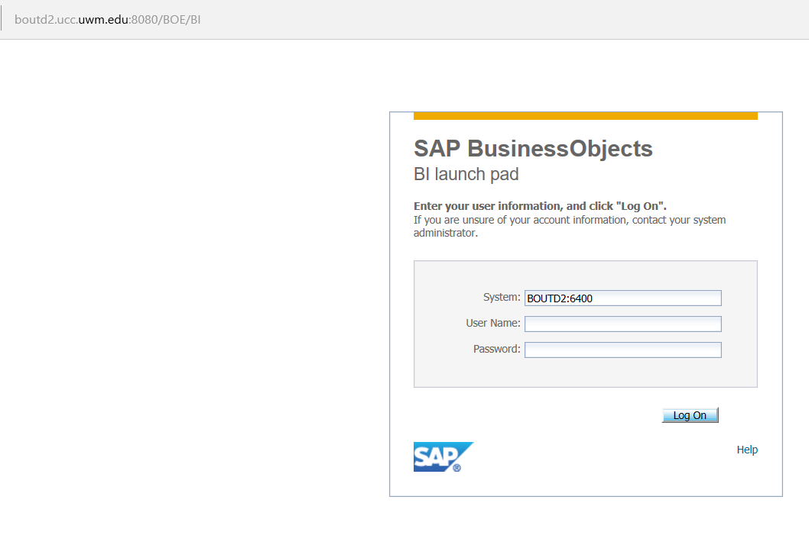

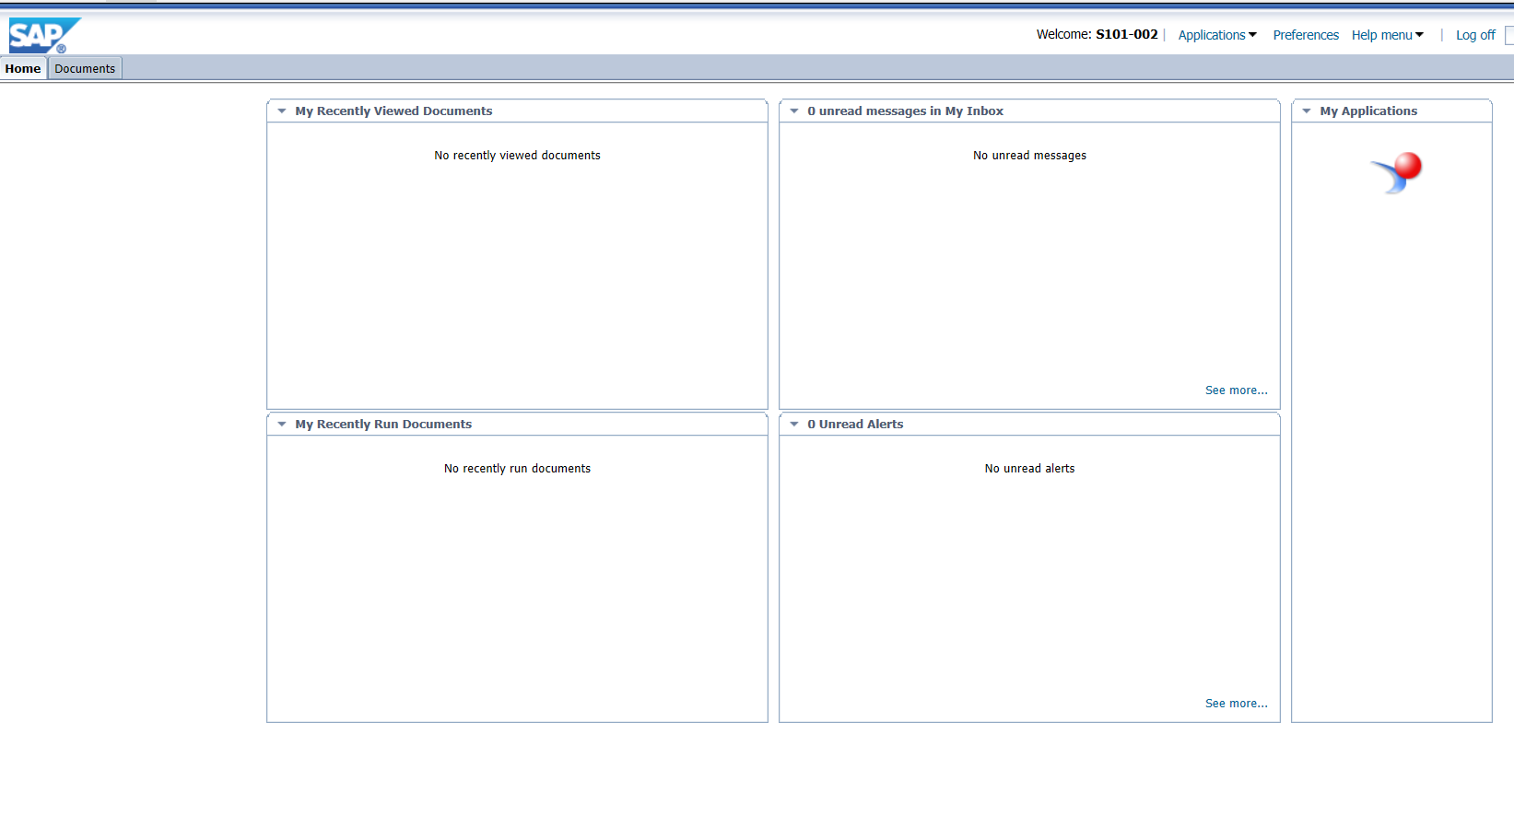

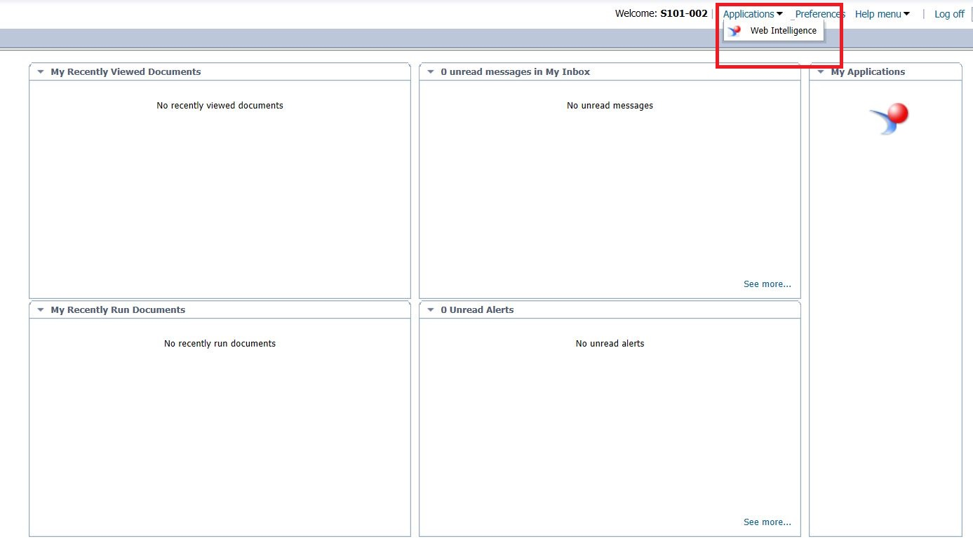

2. Select the “create new web intelligence document“ icon.

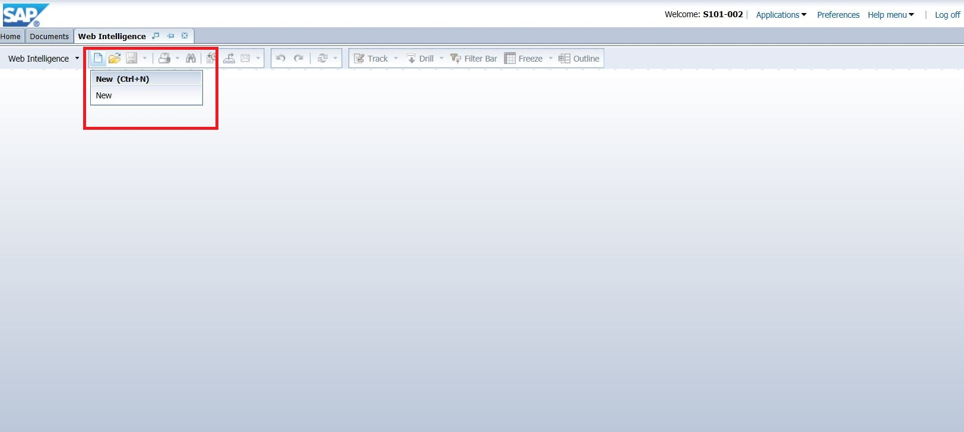

3. Now select SAP HANA as the data source.

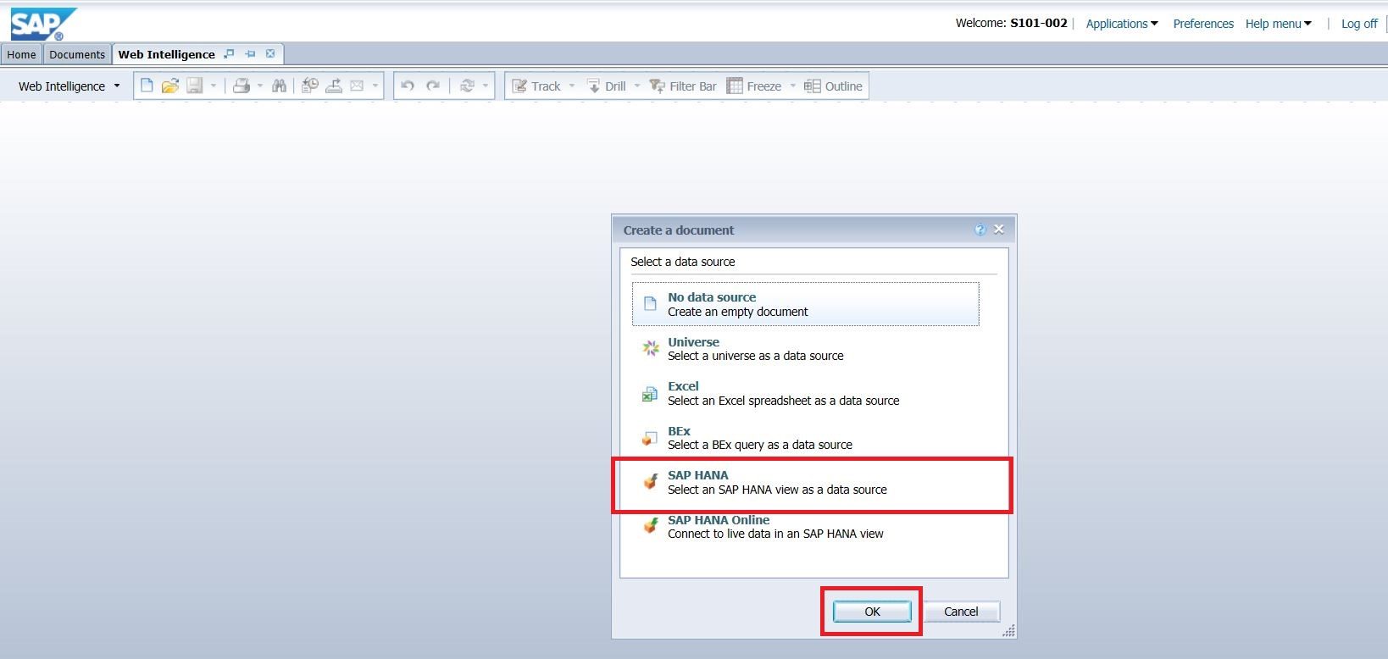

4. Select the analytical view which you have created in Exercise 6. Click Ok.

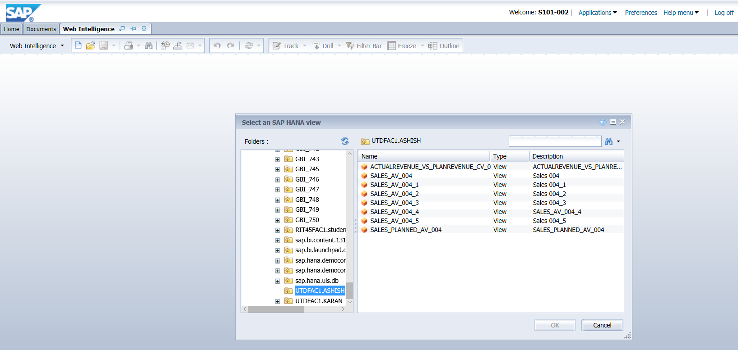

1.2 Now Create a new query by dragging the Year and Net_Sales_Revenue into the Result Objects Pane.

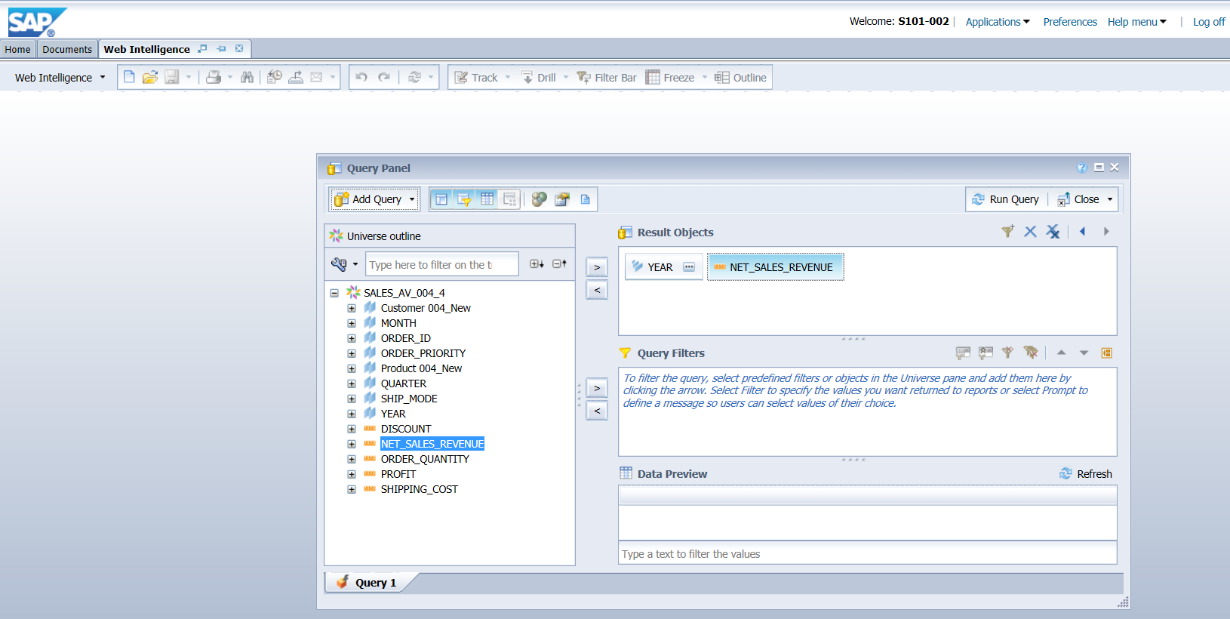

Click on the … in the Year to select the years in the Output

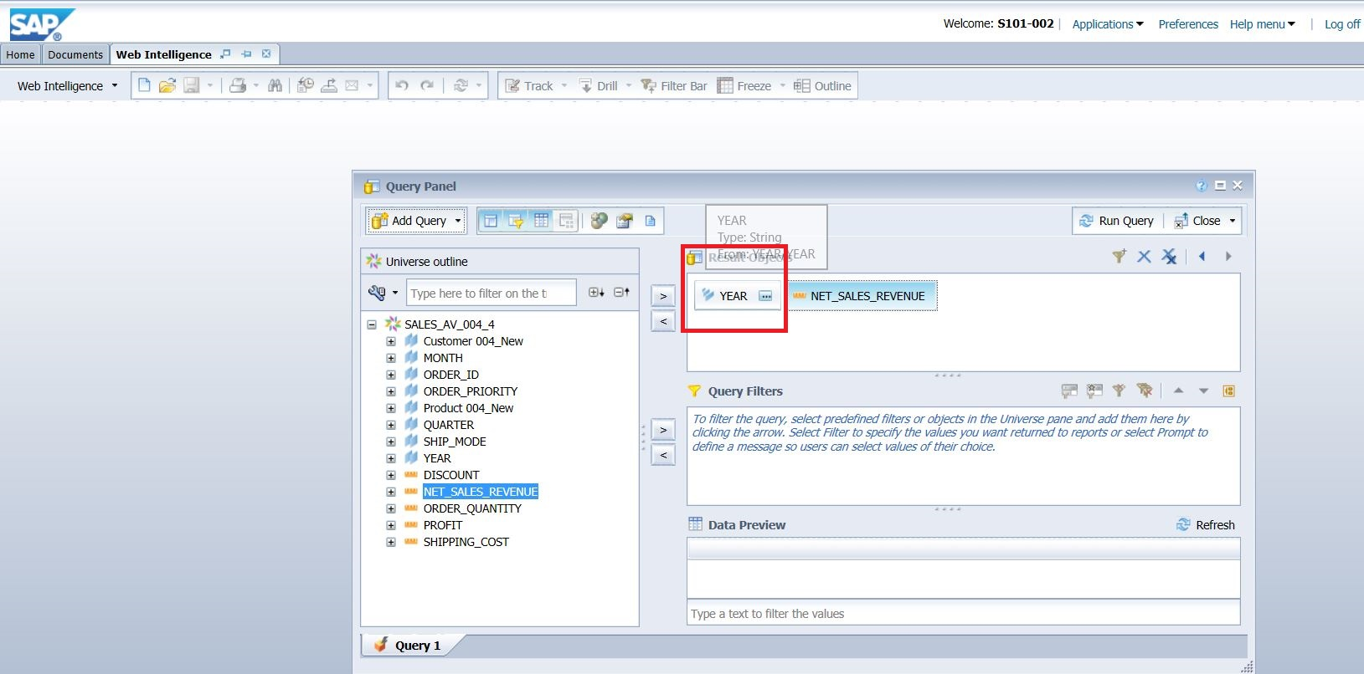

Select the years to display in the result.

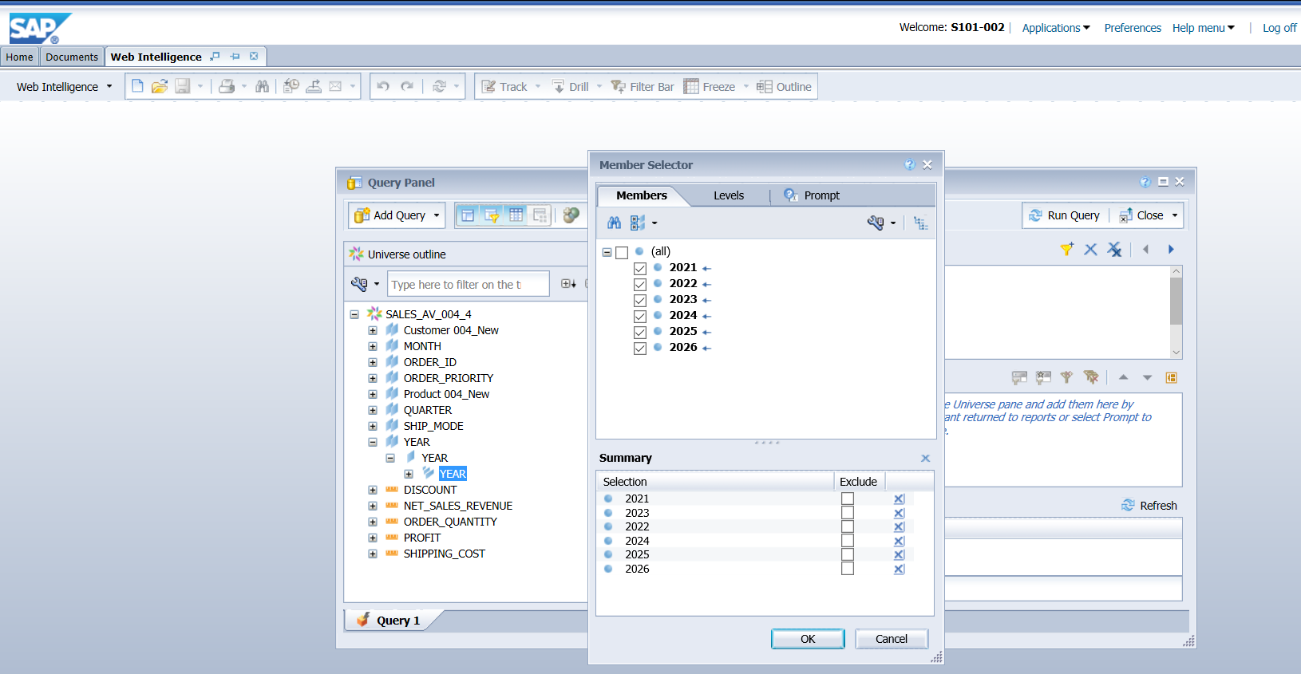

Now Run the query.

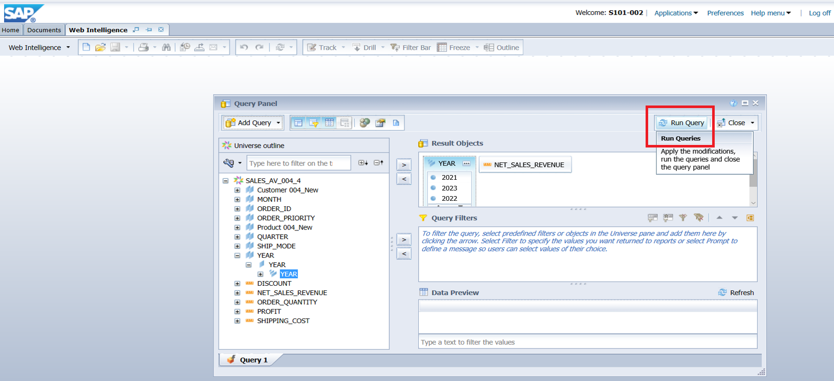

Now Select Net_Sales_Revenue column by clicking on the data of the column and go to Analysis and click on Functions tab. Click on Sum Button .

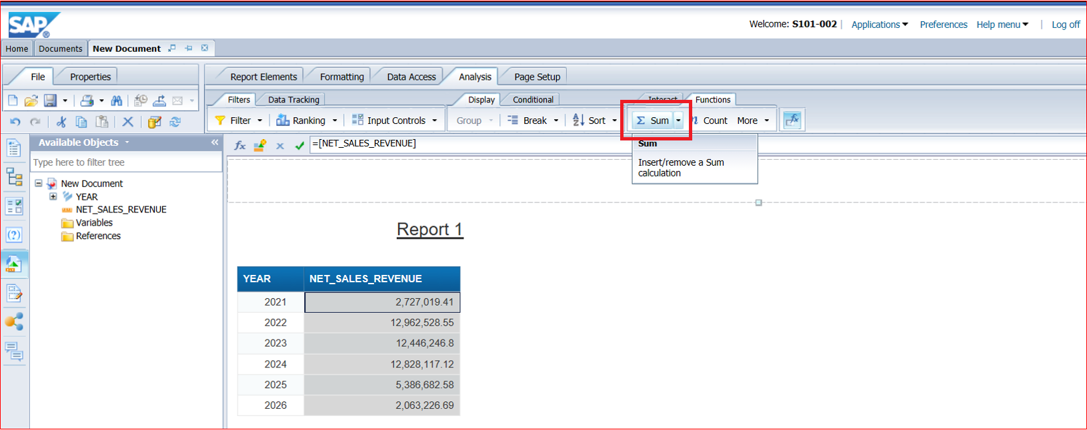

Q 1: What is the sum of the Net_Sales_Revenue for all the years?

**48,413,821.15**

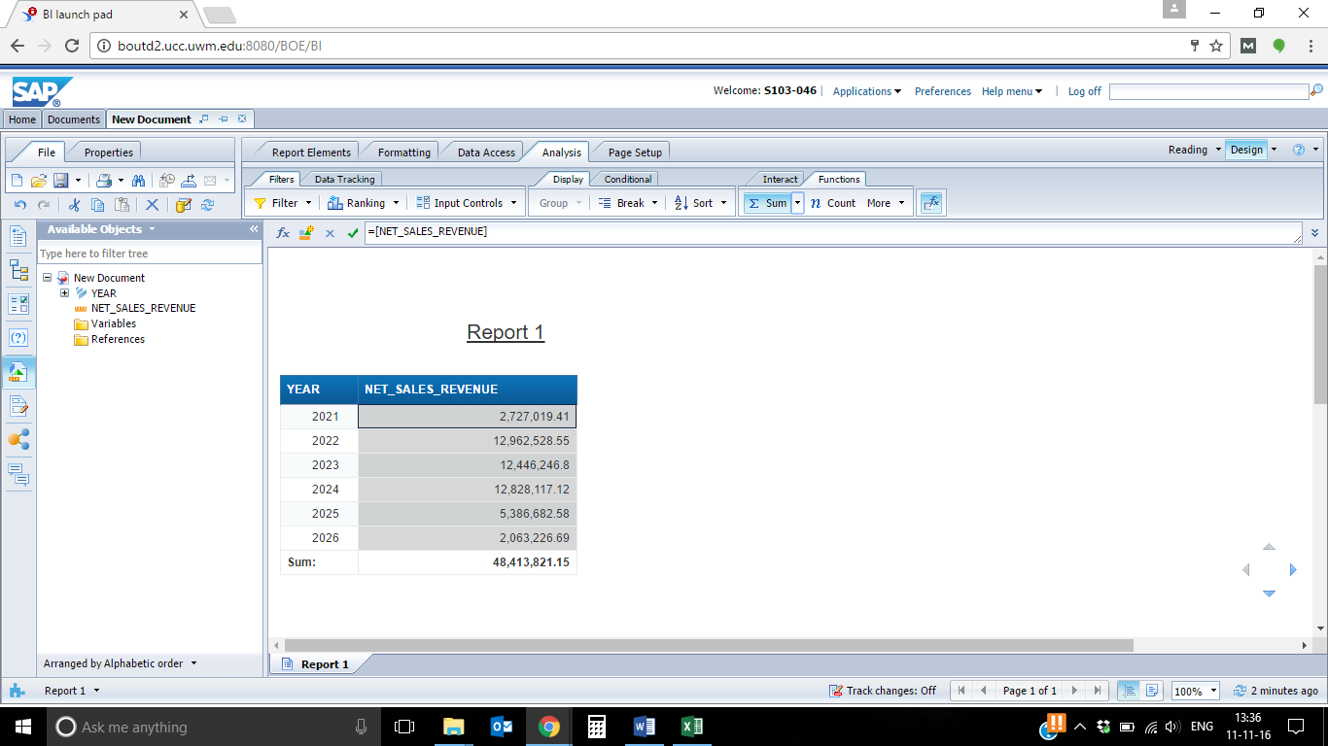

Now create a filter to show the Net_Sales_Revenue in particular Year by Region.

Now go to Data Acces->Edit and Drag the Region object to the filter pane as shown below.

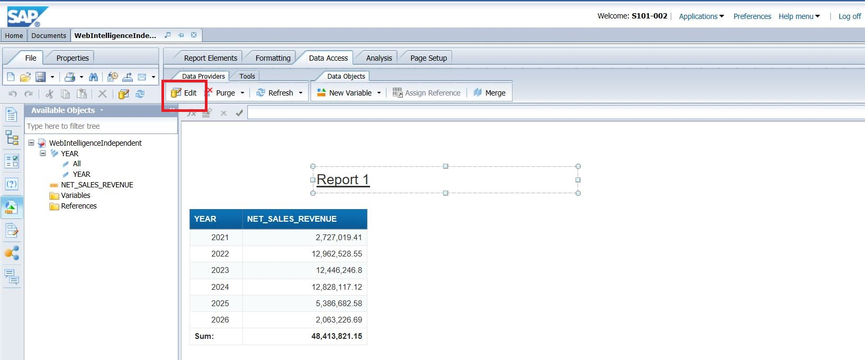

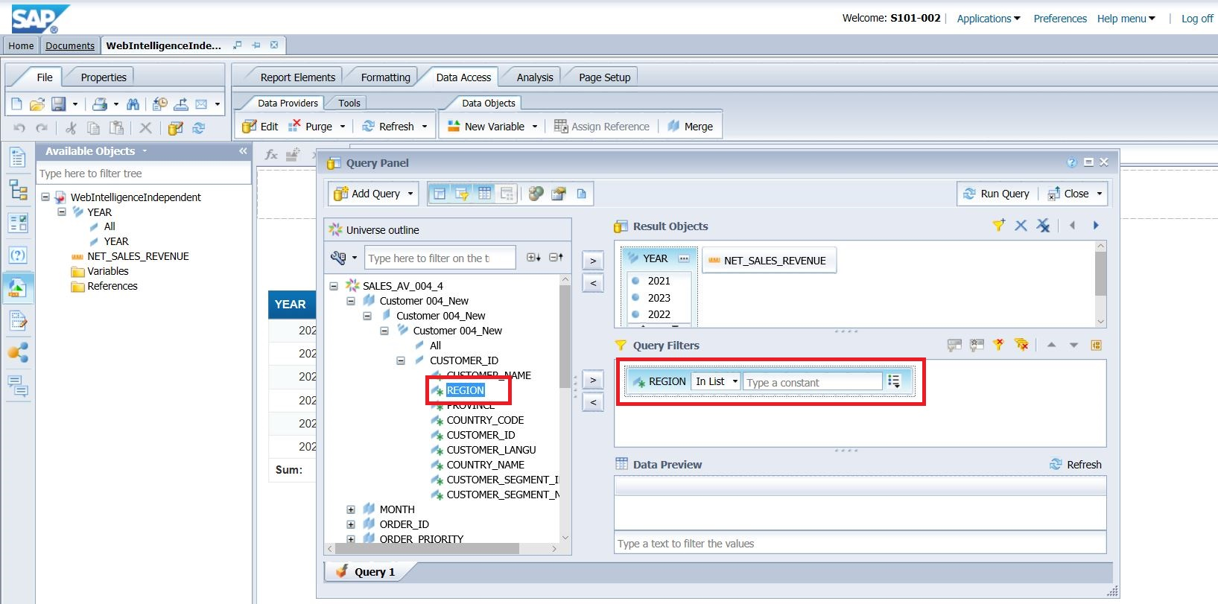

Now Region has “In List“ as the selection criterion. Click on icon in the next field and select values from list and then select only Chicago, Mexico City and British Columbia region as shown below.

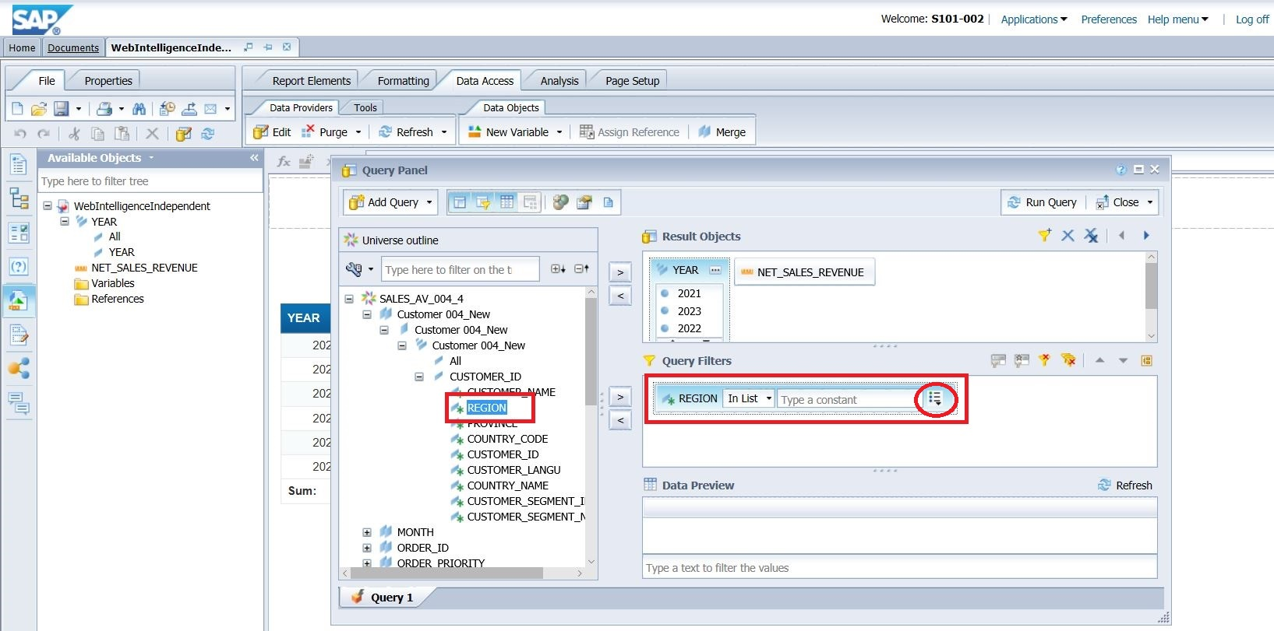

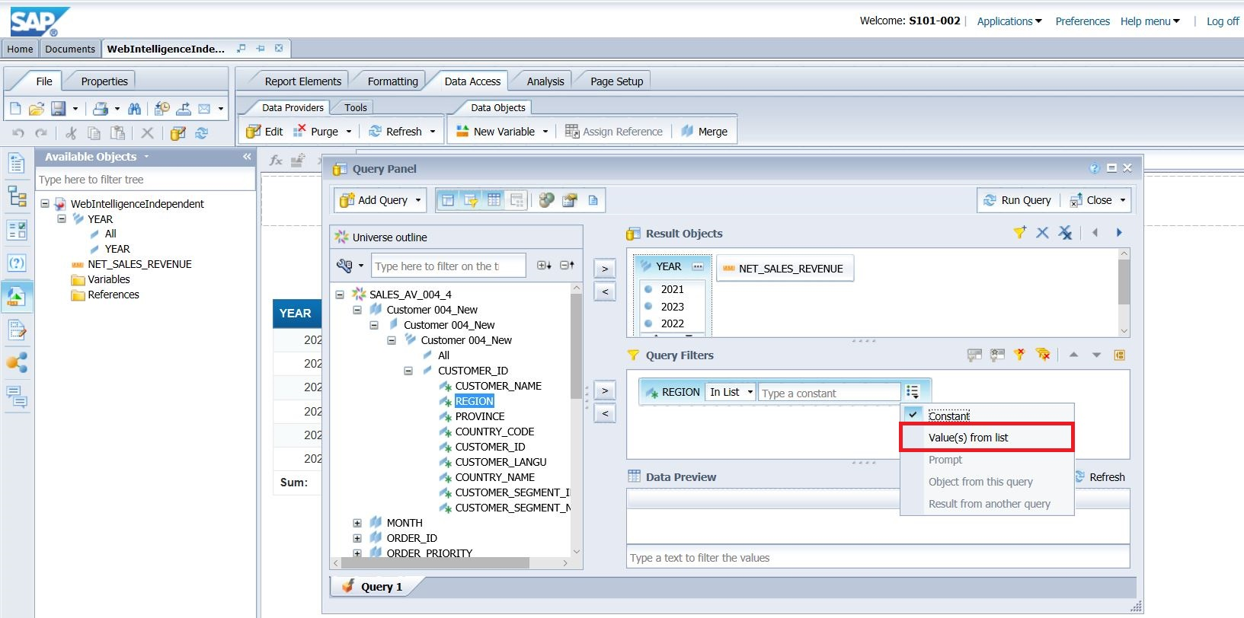

(select the right arrow mark to add a state to the pane). Click Ok. 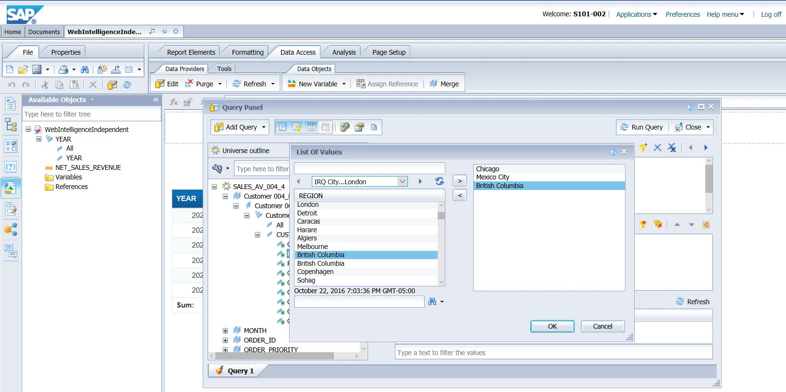

Now Run the Query.

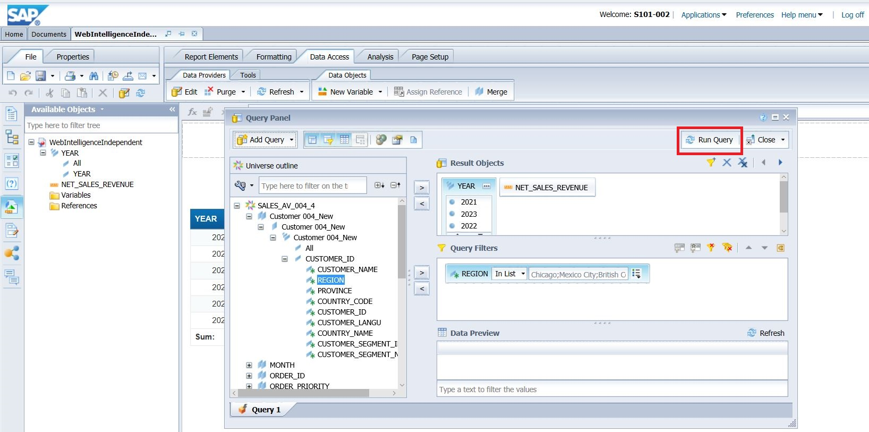

Q 2: What is the total Net_Sales_Revenue in those region mentioned above?

**1,846,671.19**

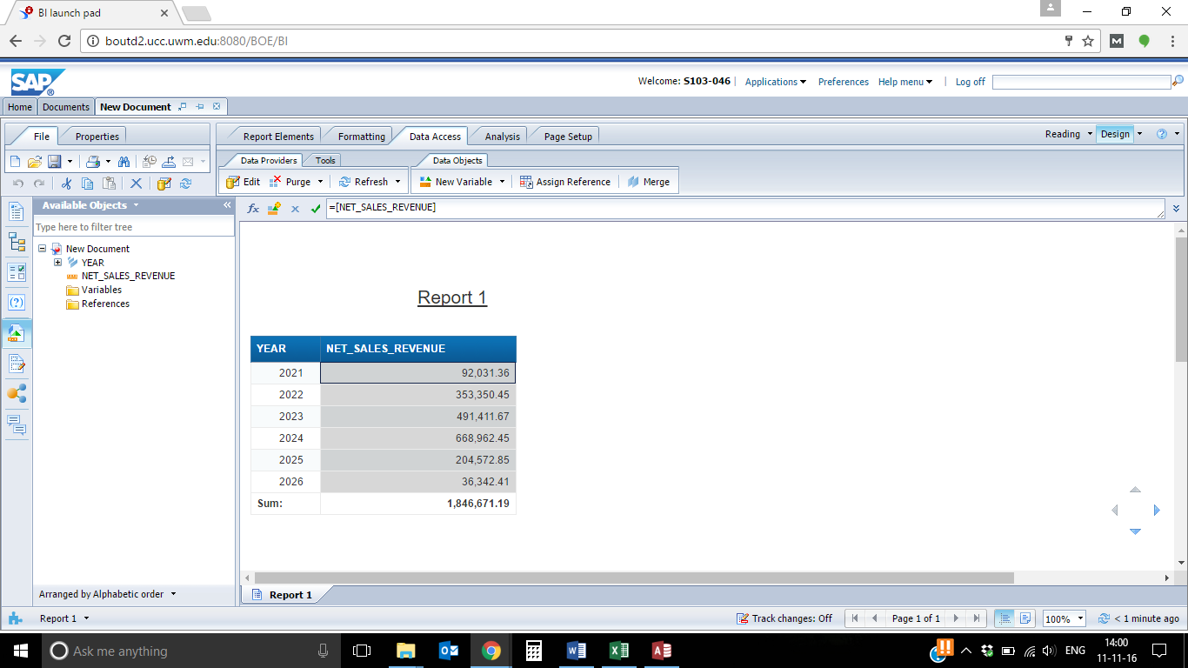

1.3 Further restrict the query by creating another filter to show Net_Sales_Revenue by year in those states for only Electrical Hardware Category.

Go to Edit and then drag Product Category Desc from Product Attribute view to the query filters pane. Specify „“Equal to“ as the selection criterion for Product Category and then in the next field, select values from list and then add Electrical Hardware to the pane.Click Ok.

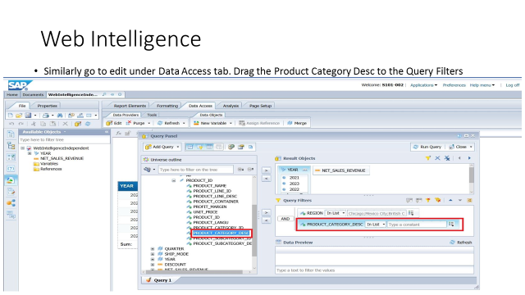

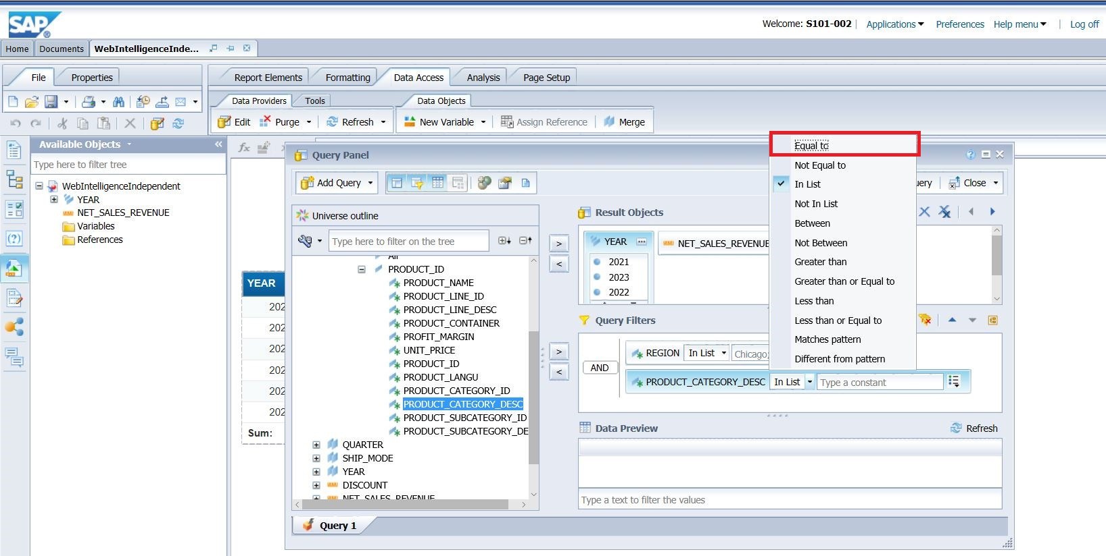

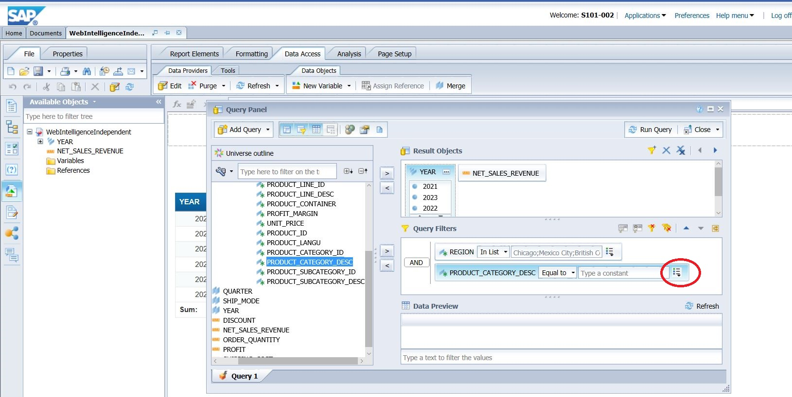

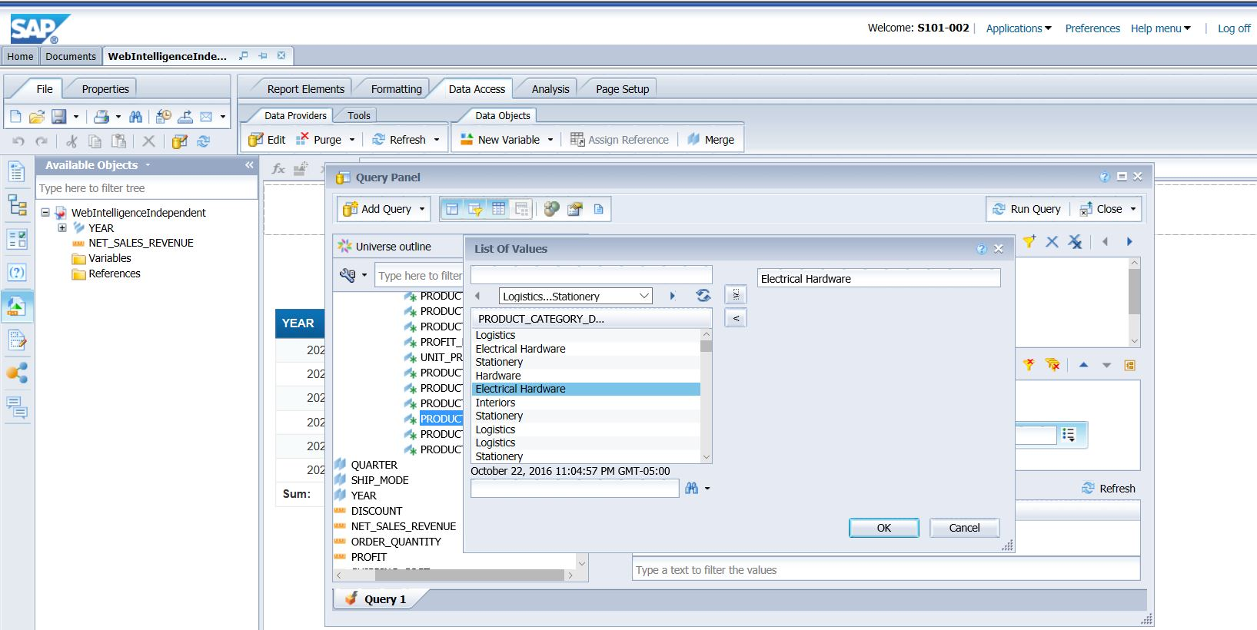

Now Run the Query.

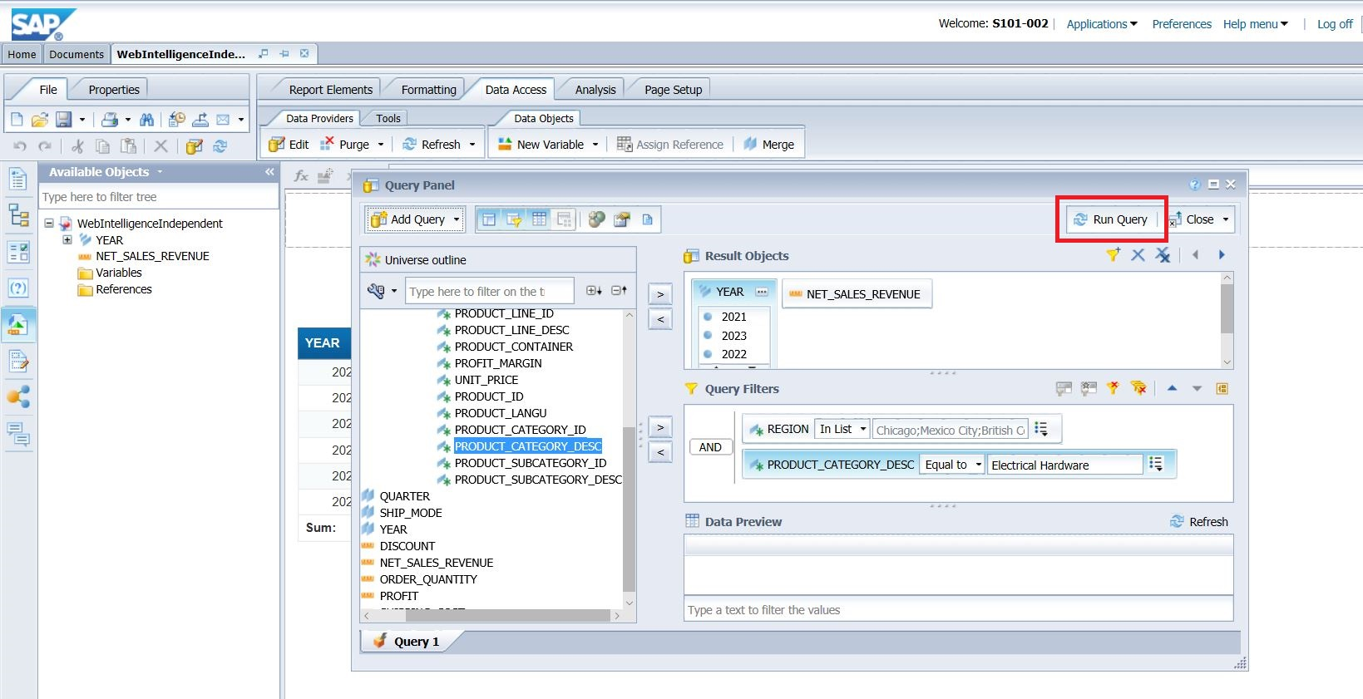

Q 3: What is the total Net_Sales_Revenue for Electrical Hardware in the region mentioned above?

**111,347.72**

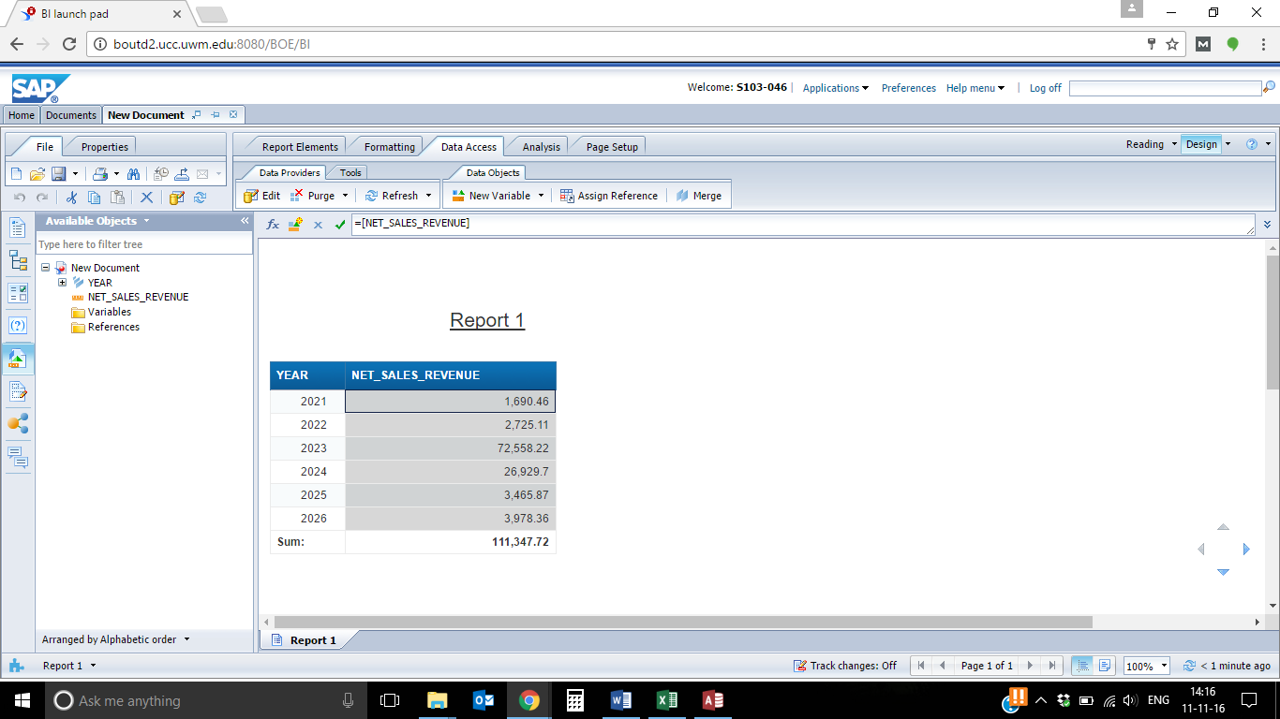

1.4 Now create a new query to display the Order Quantity by Region and Product Category Desc of the product.

1. close the current document and do not save the changes.

2. Create a new web intelligence document and select the SAP HANA.(refer to the steps mentioned above).

Create the new query by dragging Order Quantity, Region and Product Category Desc into the Results Pane as shown below. 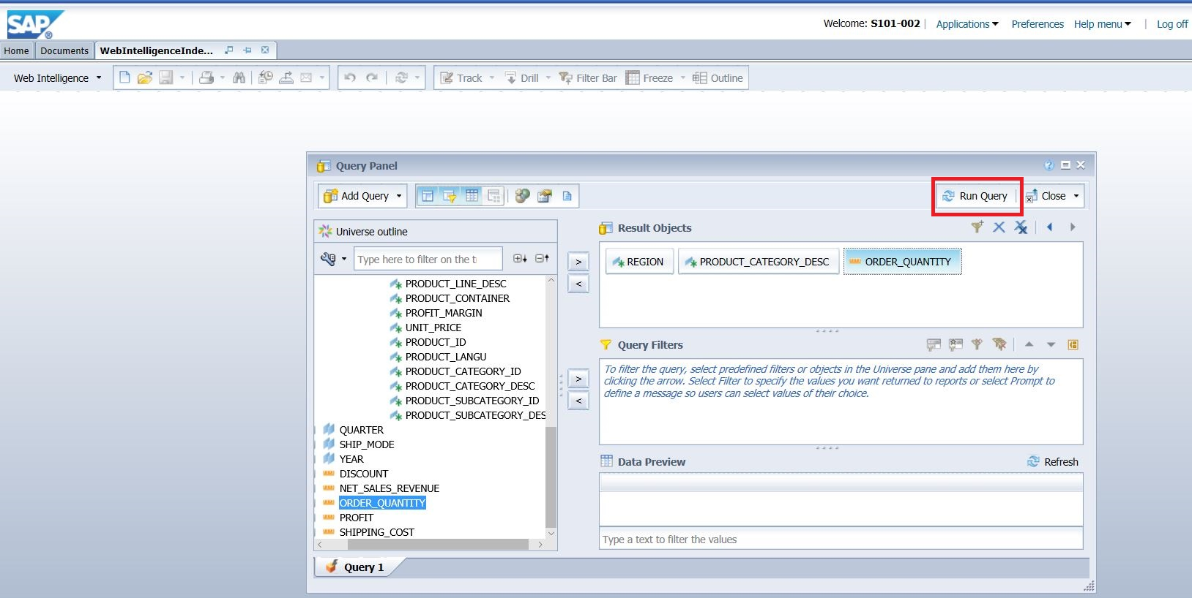

Now Run the Query. 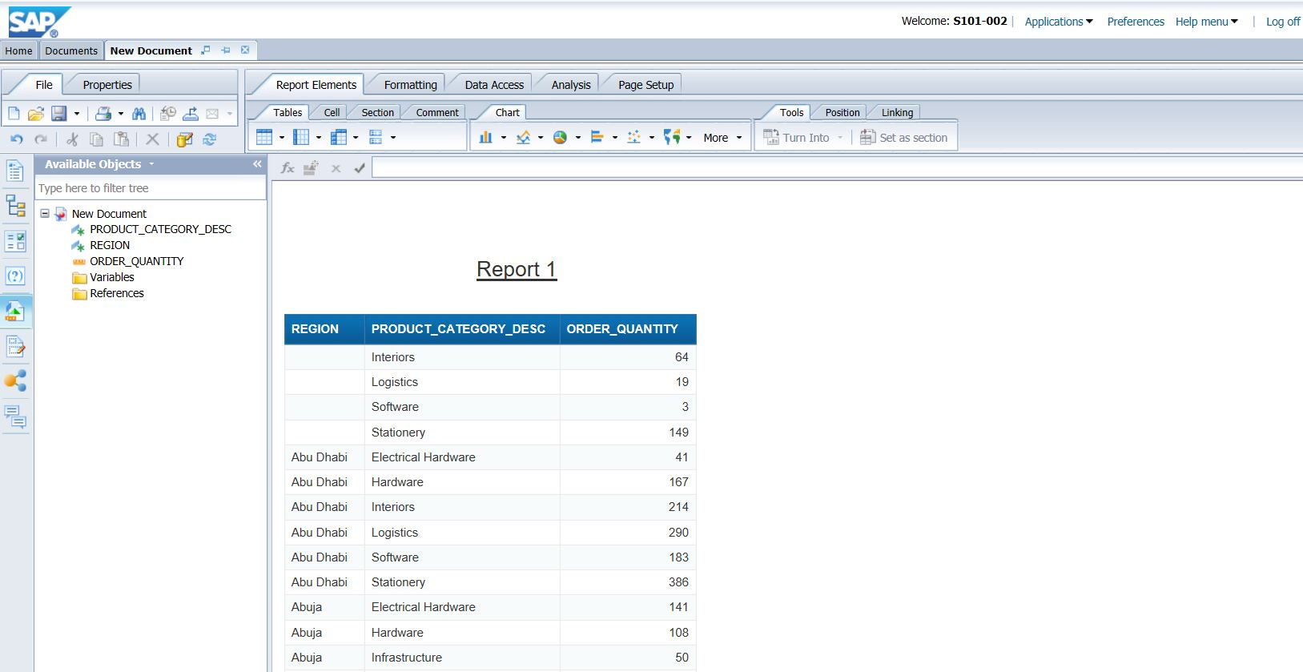

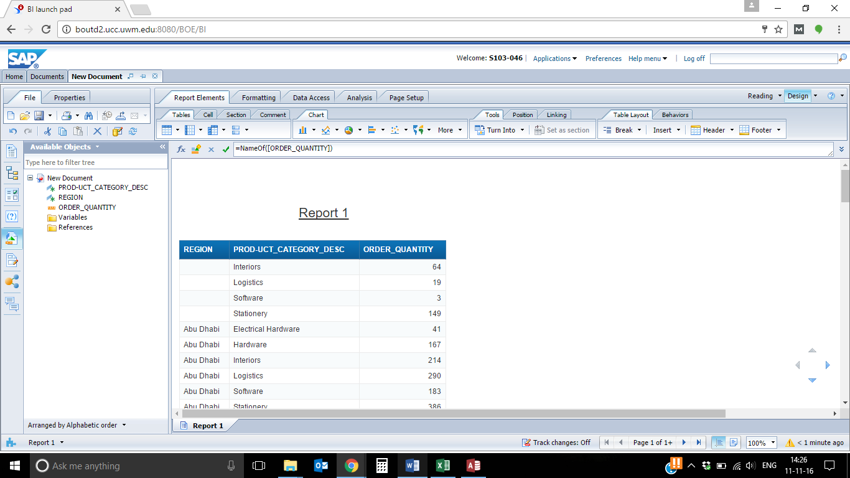

1.5 Now select the Product Category Desc column by clicking on it and then right click and select turn-into and then a crosstable. 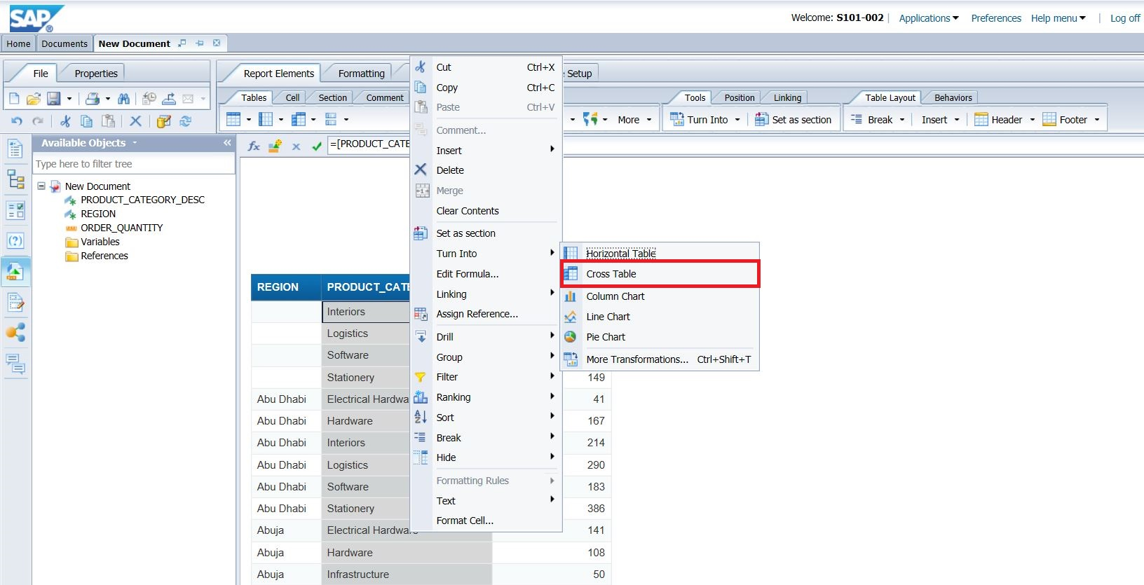

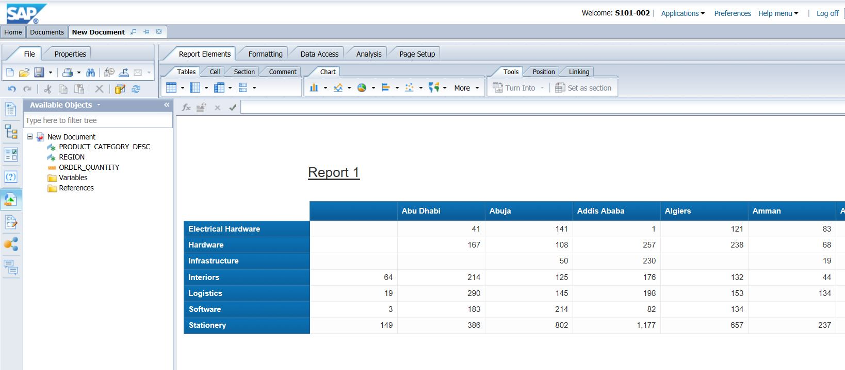

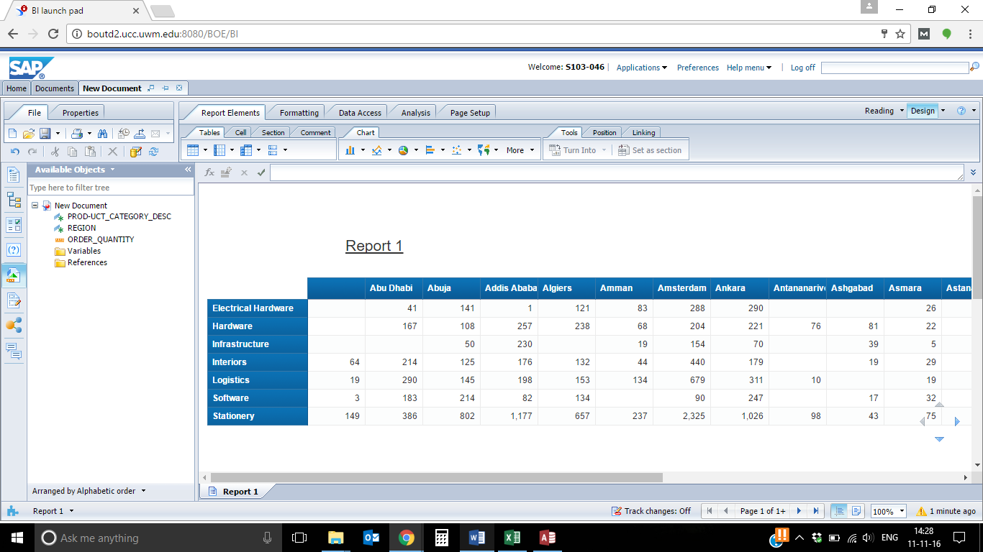

1.6 Now select the data inside the crosstable by clicking on it and then go to Analysis->Functions and then click on sum button. If a pop-up windows comes, select both rows and columns, click Ok.

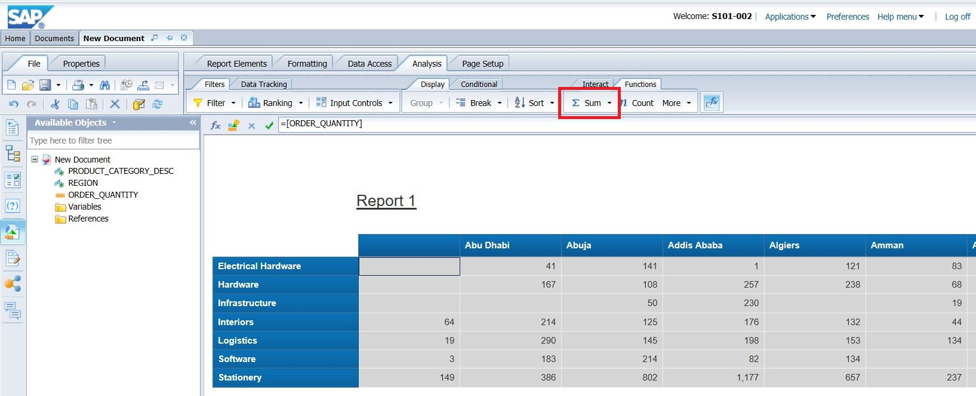

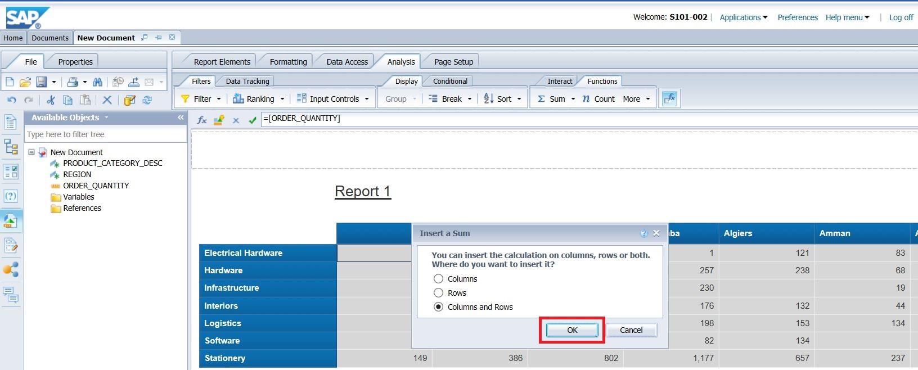

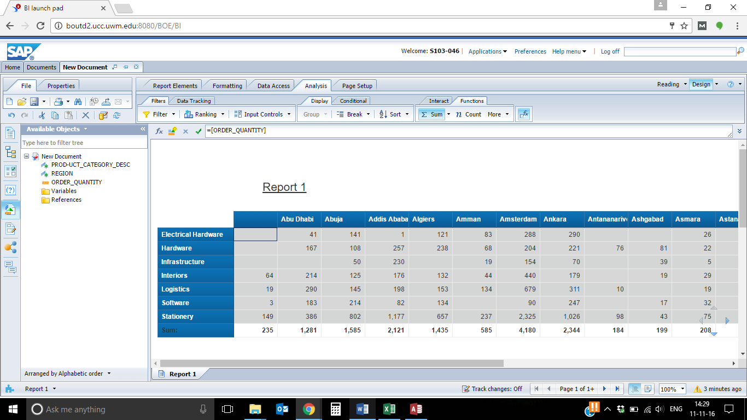

Q 4: How many Electrical Hardware were sold in Abu Dhabi?

**41**

Q 5: What is the number of Software sold from Amman?

0

1.7 Now change the query by removing Category dimension object and adding Year dimension object.

Drag the Year dimension object and drop it onto the column of the cross tab. What does the analysis show now?

Steps :

1. Go back to edit query window. Drag Product Category Desc out of the results objects and Drag Year into the pane. Run the query. ( See below)
2. Now Drag the year object onto the Column heading as shown below

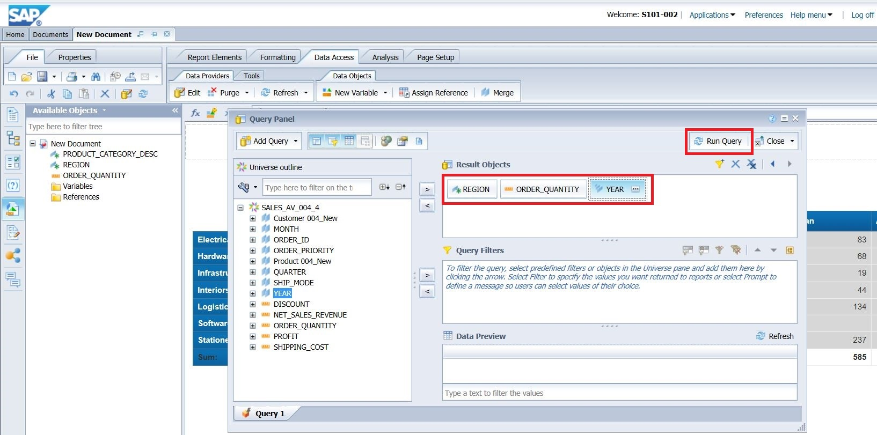

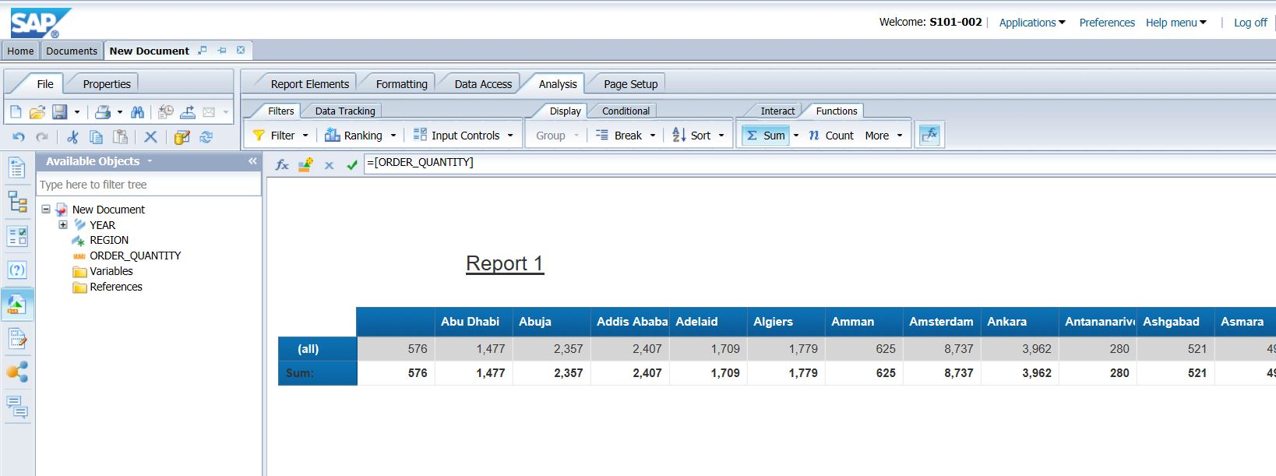

The analysis now shows the sales quantity by State and Year.

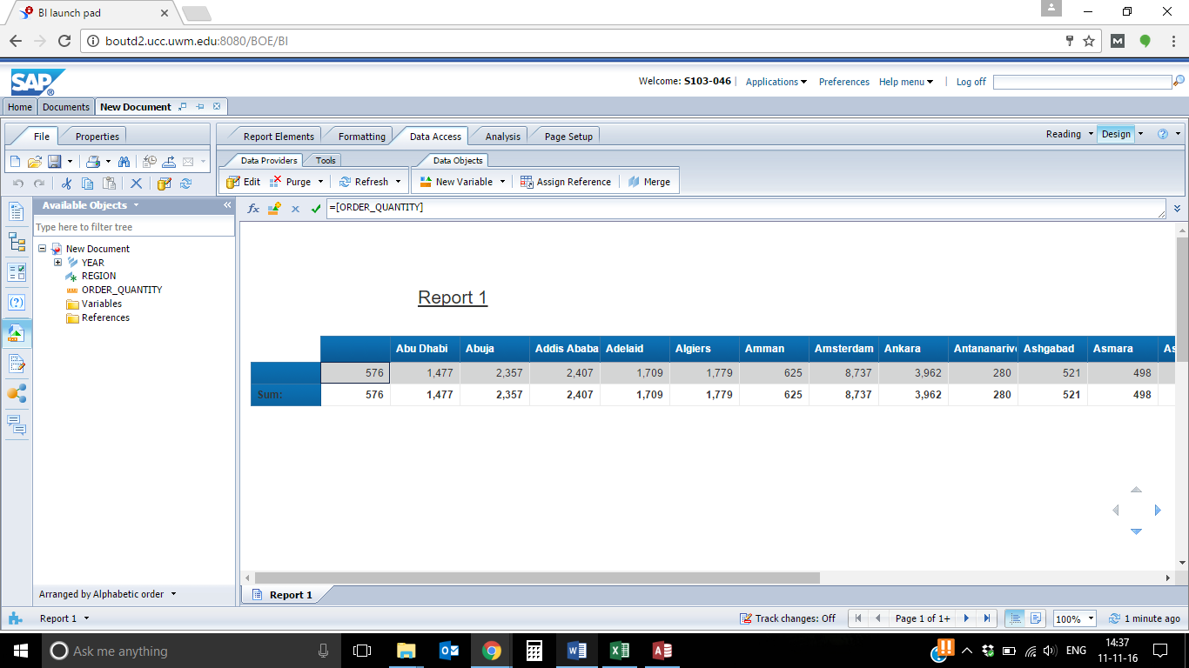

**Part 2**

2.1 Create a new web Intelligence document showing the Year, Month, Net Sales Revenue, Region, Product Category Desc.

1. Close any open documents
2. Select the SAP HANA as mentioned in the previous steps.
3. Create a new query by dragging Year, Month, Net Sales Revenue, Region and Product Category Desc objects on to the Result Objects pane (as shown below). Run the query.

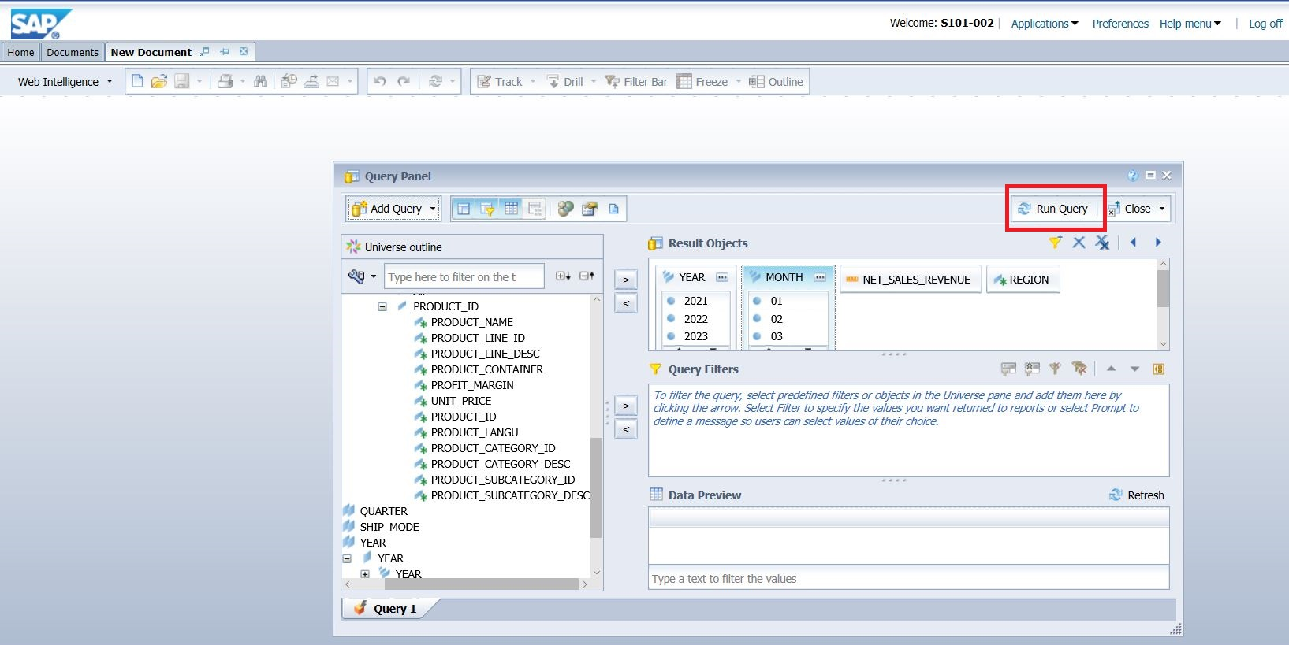

2.2

**Sections:**

1.Create a section using the Region object.

2.Create another section using the Product Category Desc object.

Steps :

Select the data in the Region column by clicking it and then right click and choose “Set as Section“ as shown below.

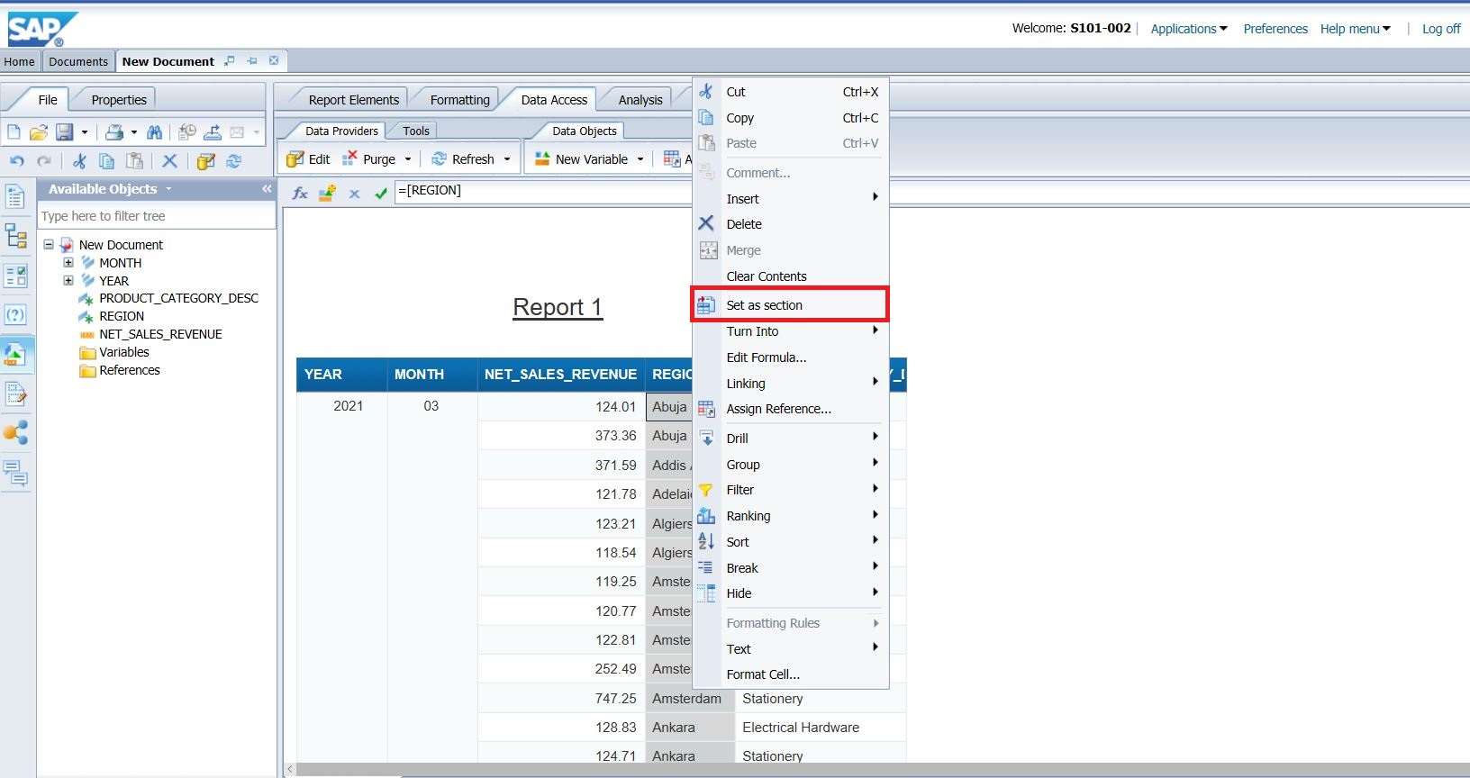

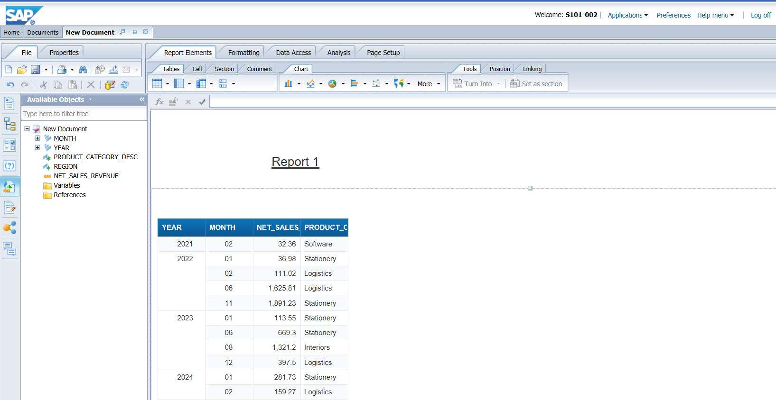

2.Do the same to create another section on category.

2.3

**Breaks:**

Create a **break** on the Month column.

Steps:

Select the Month column by clicking on it and then click on Break in the tool bar.

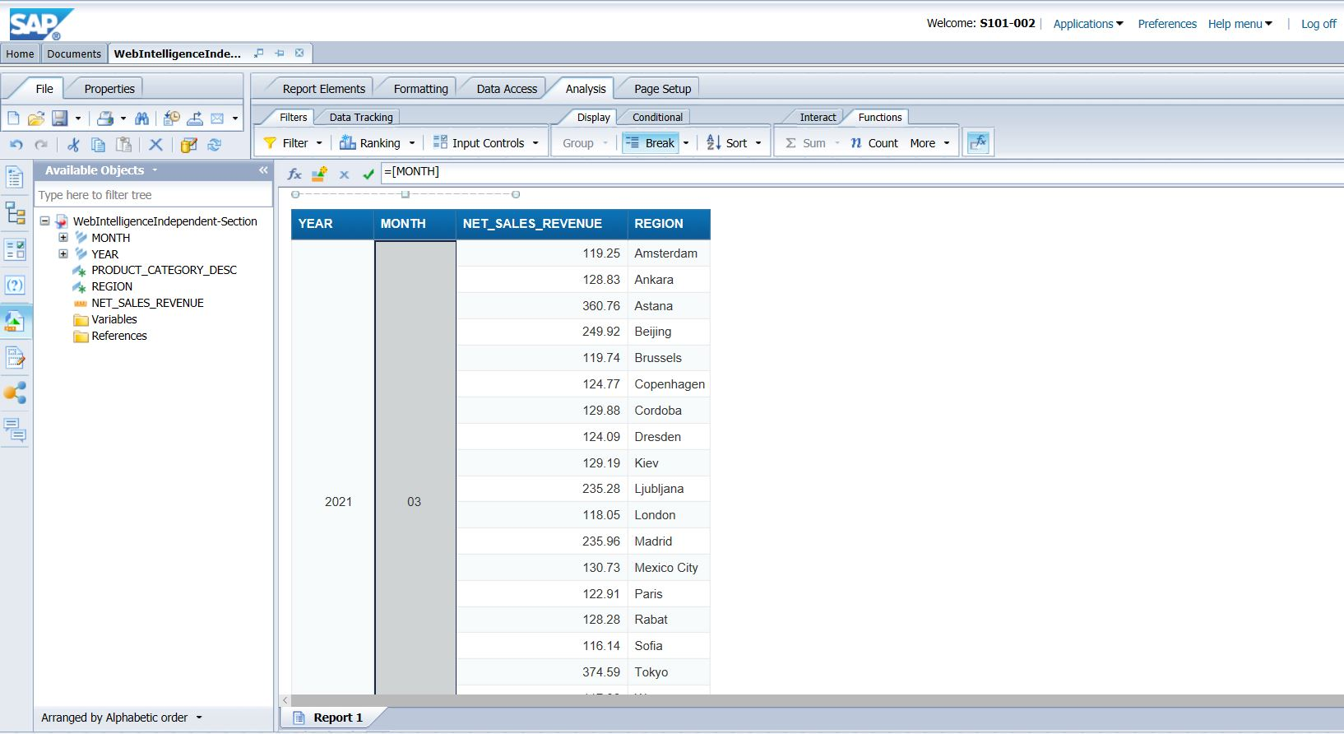

Now Select Revenue column and Insert Sum.

Q 9. Display the sum of revenue for Electrical Hardware in 2021 for 3rd and 4th month.

**3,433.94 : 3rd month**

**3220.96 : 4th month**

**Paste the screen shot**

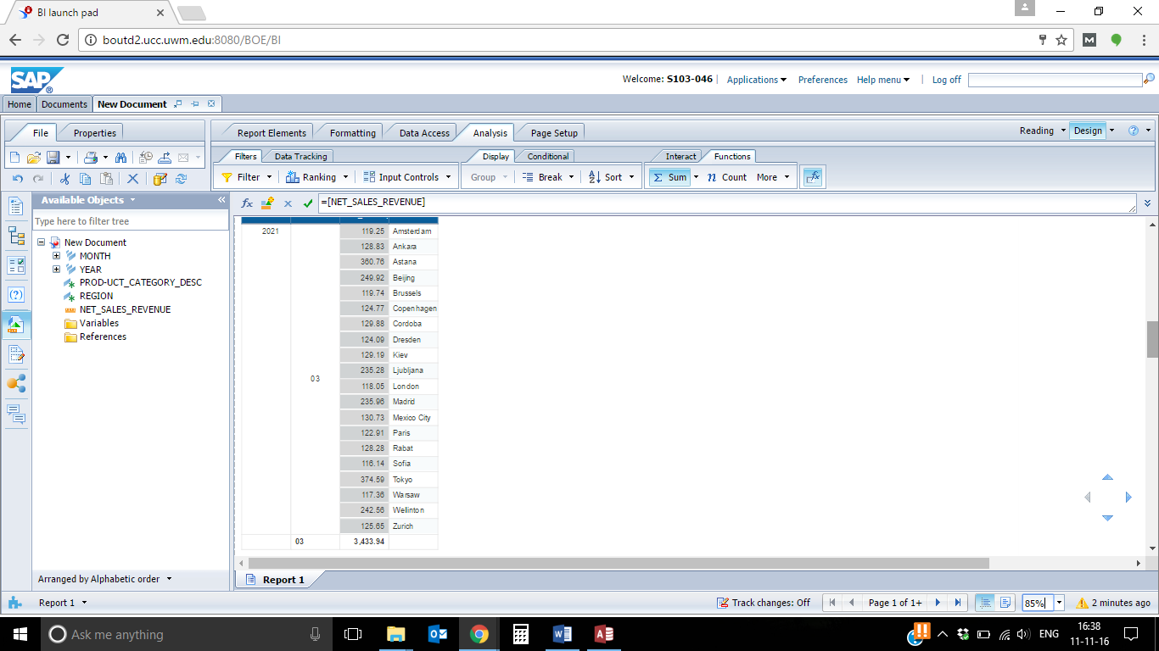

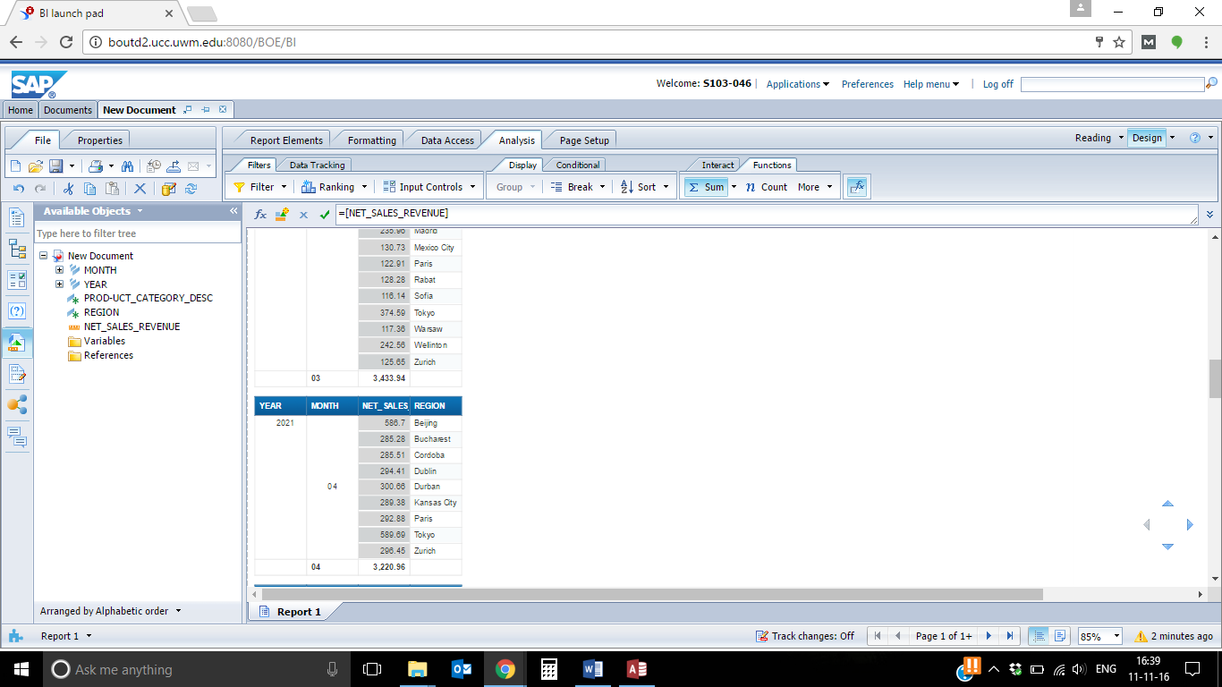

2.4

Display the Sum of Net Sales Revenue for all Year under Product Category Desc Section header.

Steps:

1. Select the Net Sales Revenue Column field, Hold the Ctrl key and rag and drop the fields as shown below.

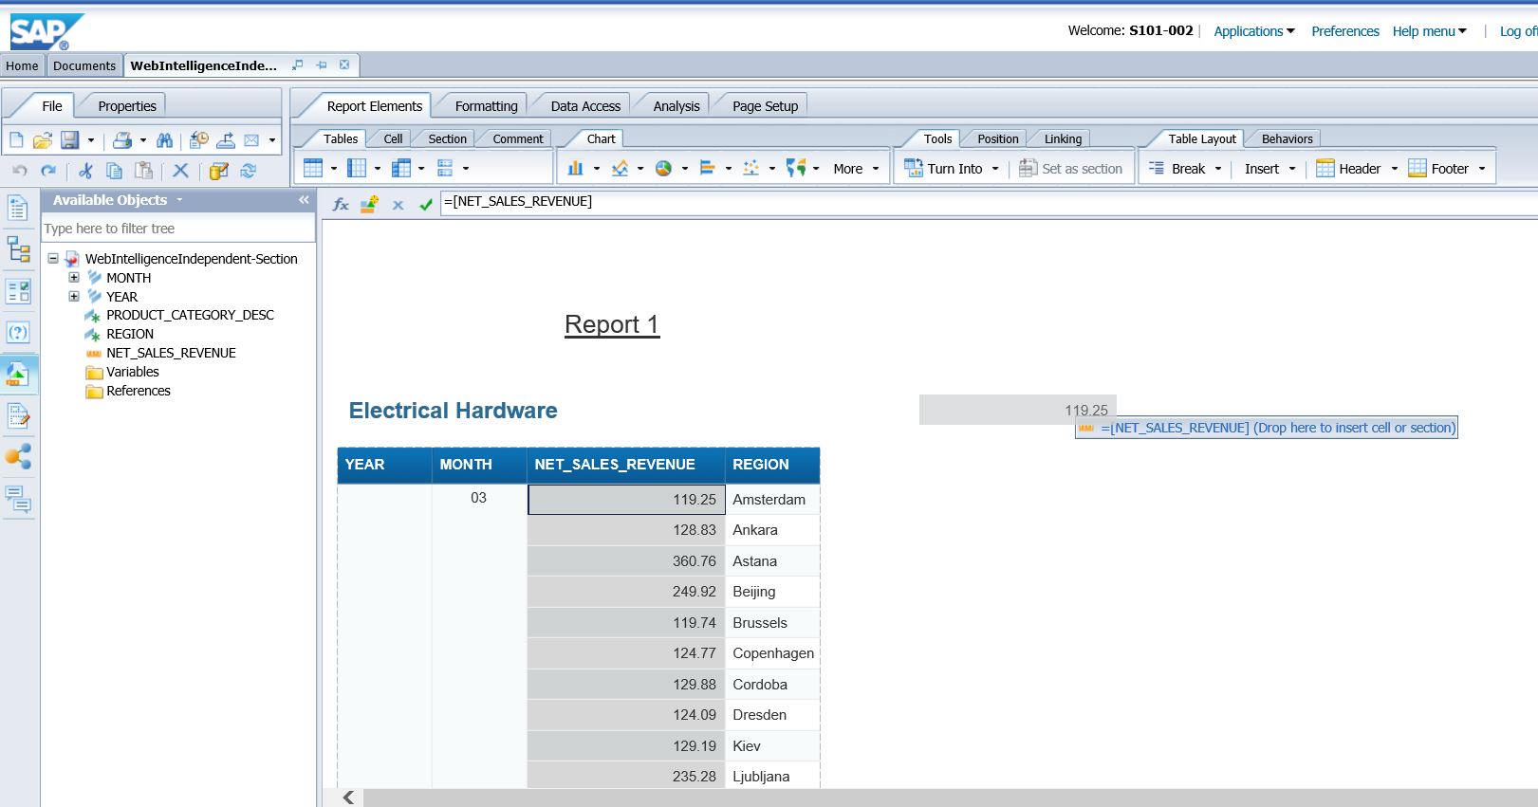

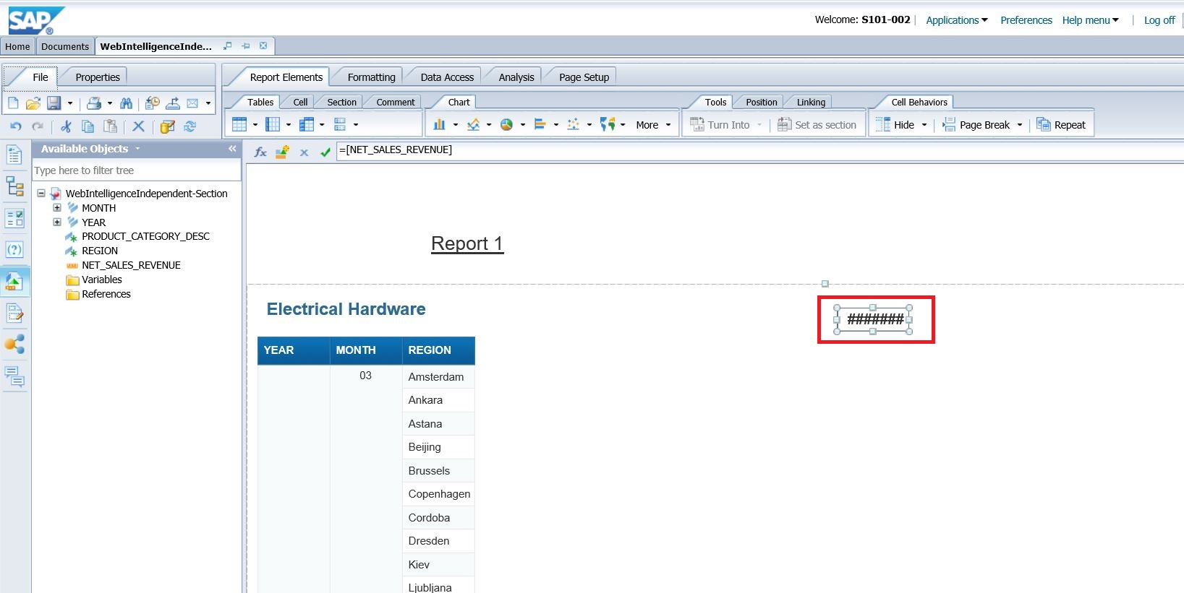

Expand the highlighted portion and get the total Net Sales Revenue.

What is the total Net Sales Revenue for Electrical Hardware?

**2,158,331.25**

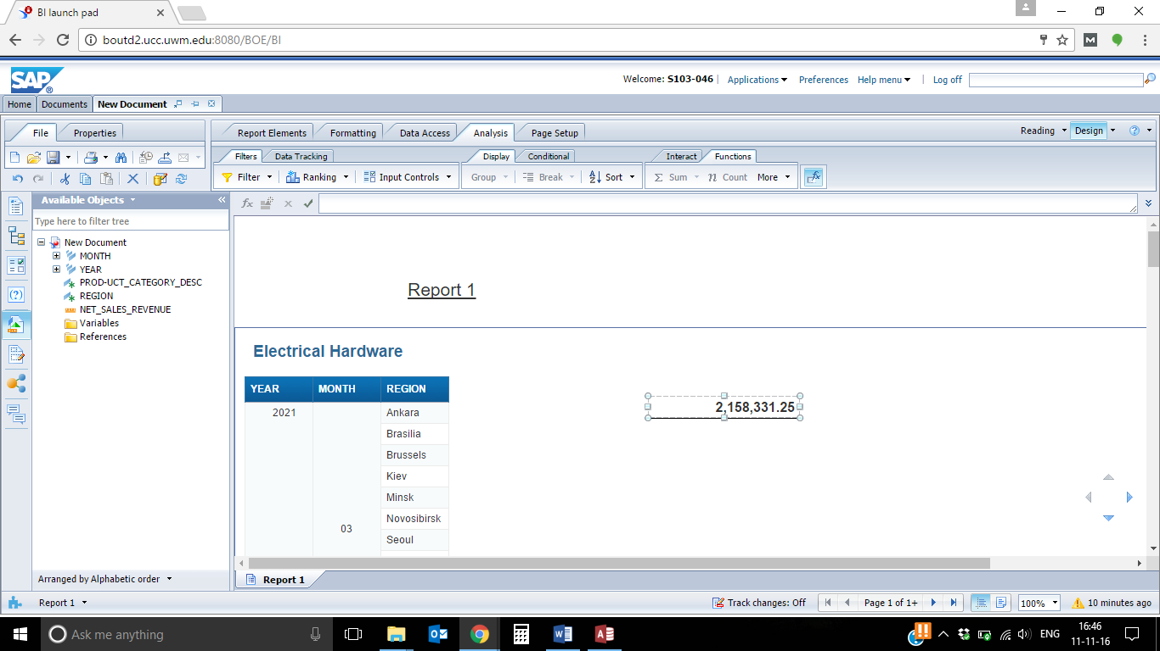

**2.5** **Charts**

1. Create a Column Chart to display the Net Sales Revenue (Y-axis) by Year (X-axis) and Product Category Desc(Z-axis). Position this chart in the State Section.

2. Ensure the Legend is visible.

3. Reposition the Graph if necessary.

Go to Report elements tab and then click on chart. Select the column chart. Place it into the Product Category Desc Section as shown below.

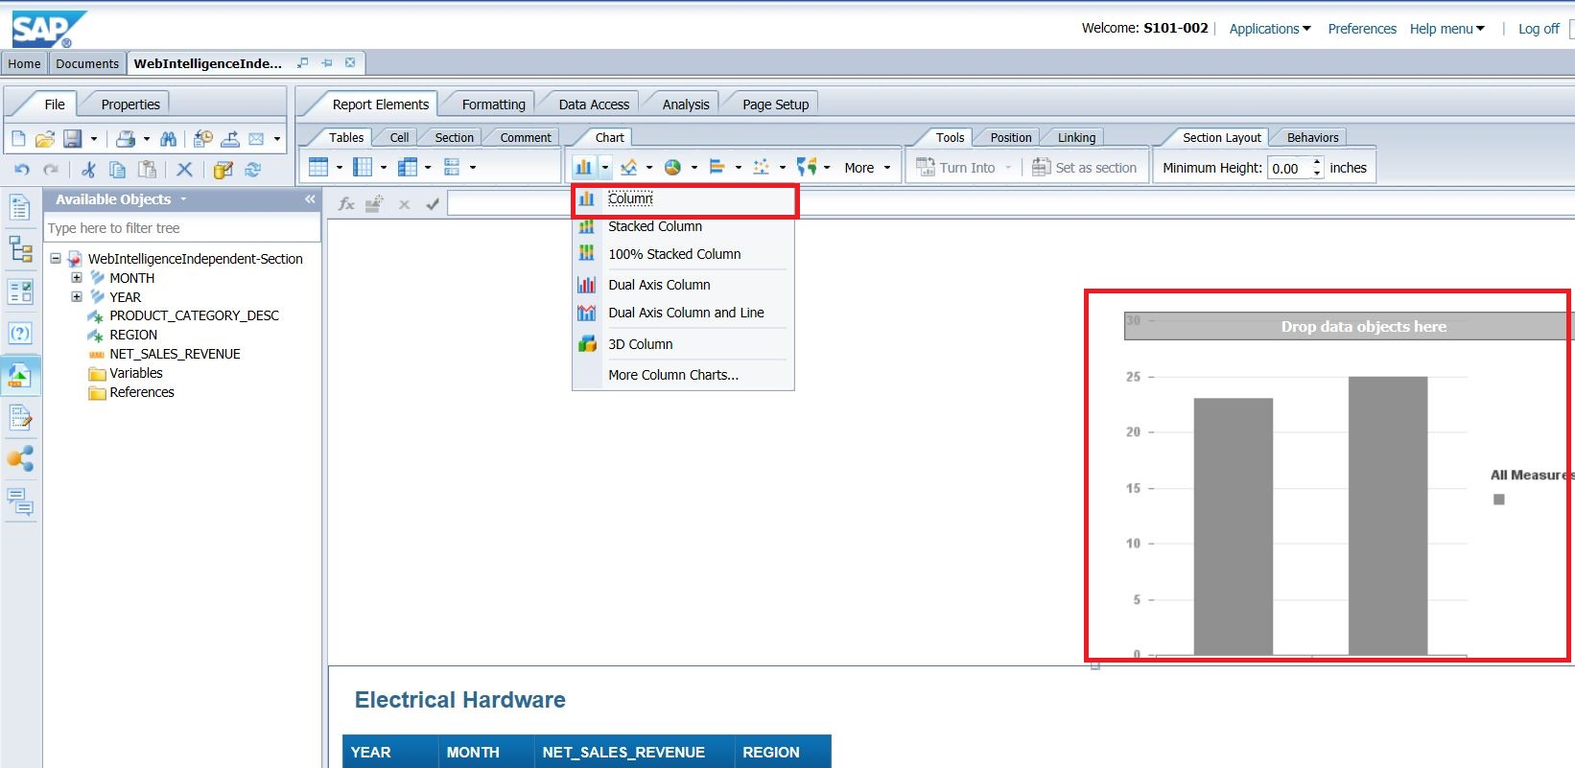

Right click on chart and click on Assign Data

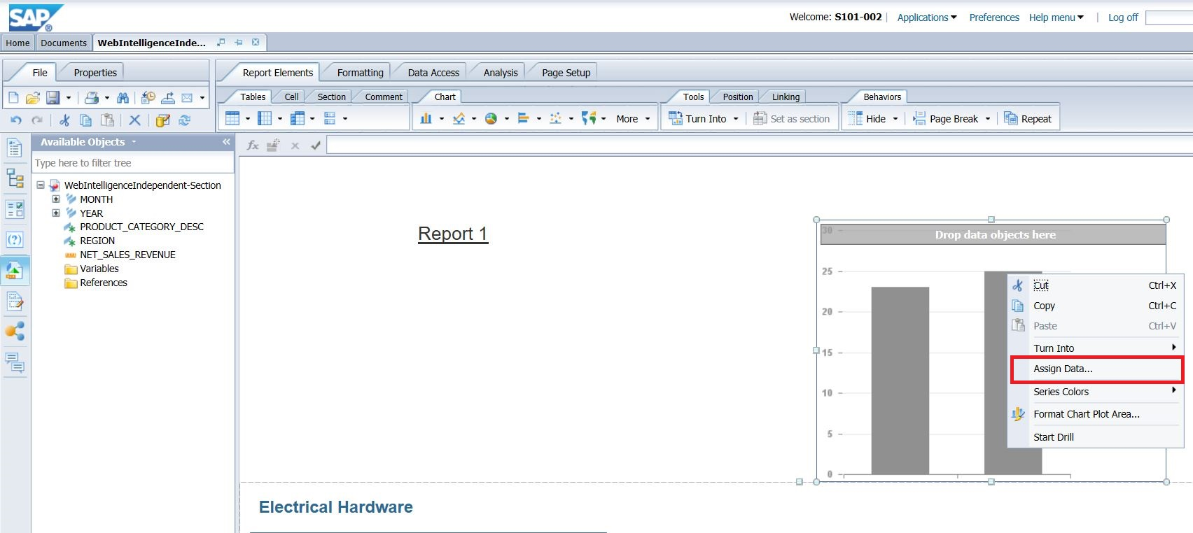

The below screen will come. Click on little arrow.

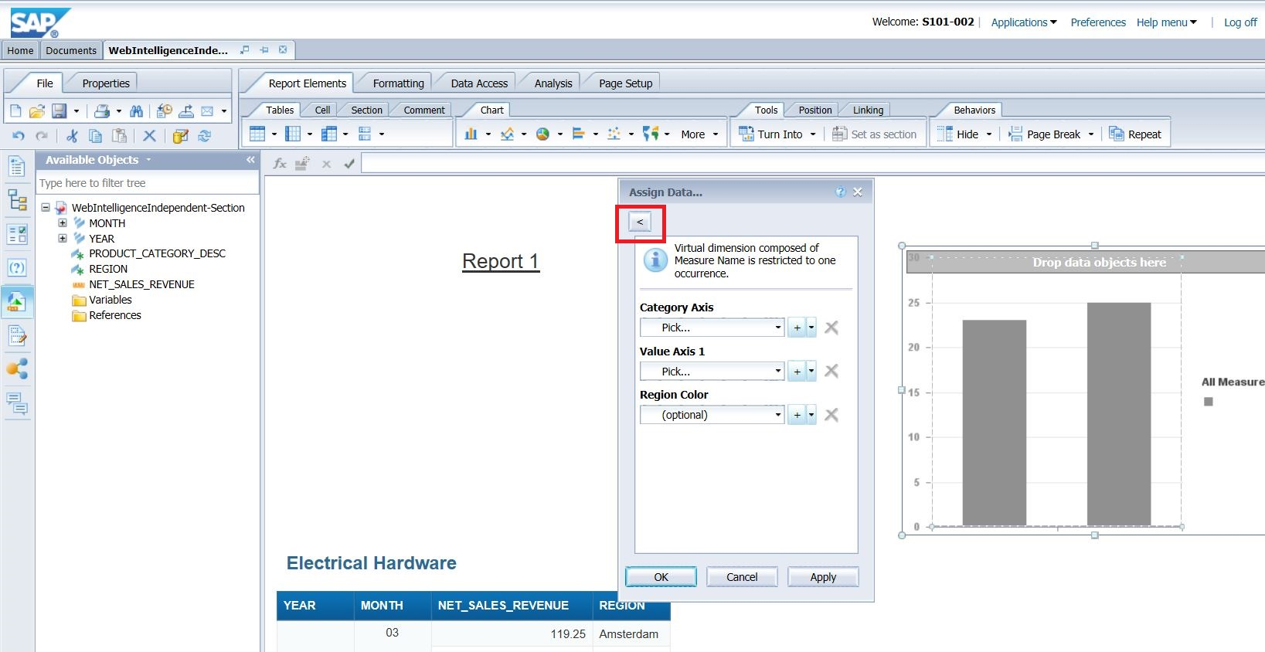

Now select Sales Revenue for Y-axis, Category for Z-axis and Year for X-axis as shown below.

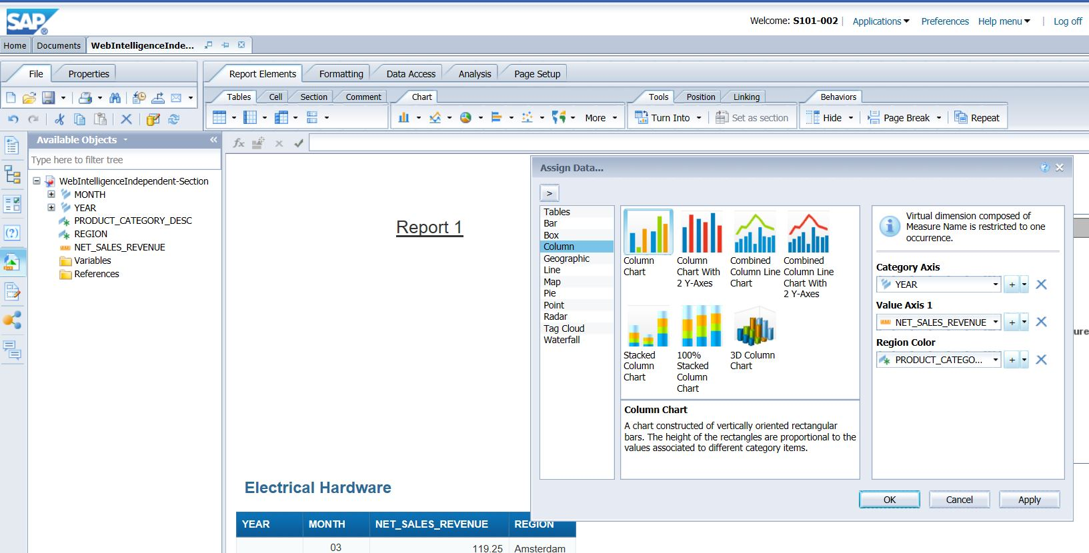

Reposition the chart so that it is below the State heading as shown below.

Q 3.Paste the Screenshot of the results.

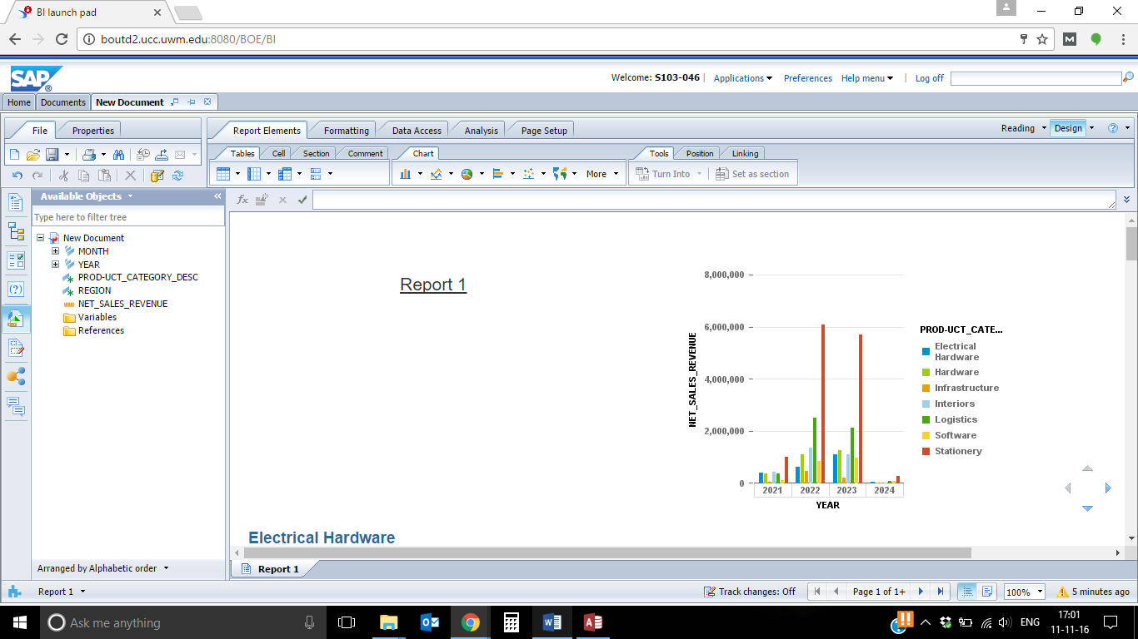

**2.6** Create a 3D chart to display the Net Sales Revenue on Y-axis, Year on X-axis and Month on Z-axis. Position this chart in the Product Category Desc section to the right of the table. Reposition the graph if necessary. See below.

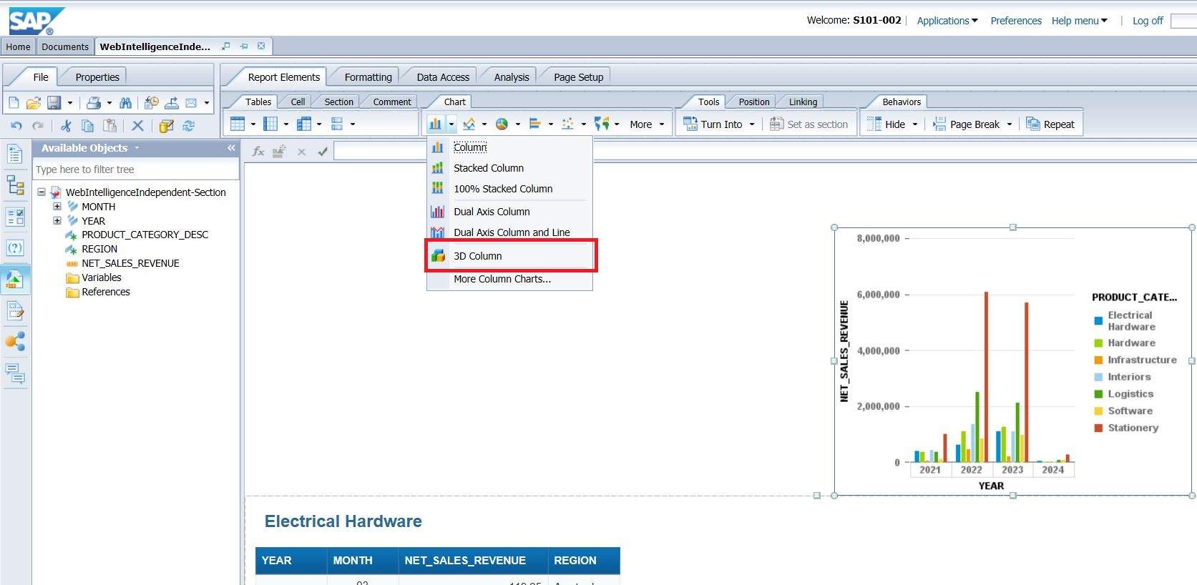

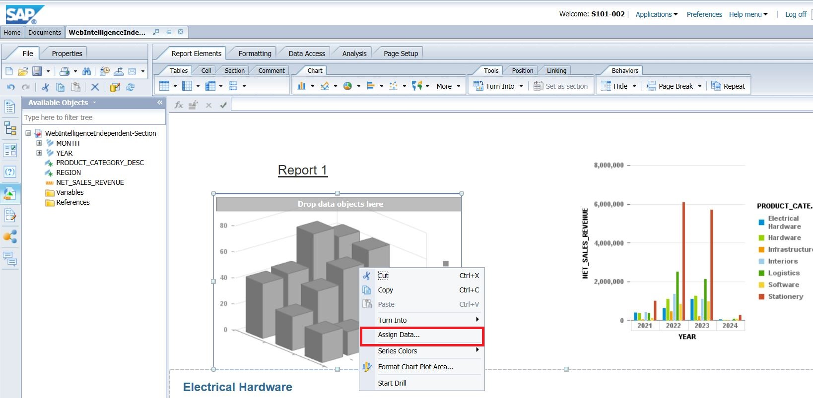

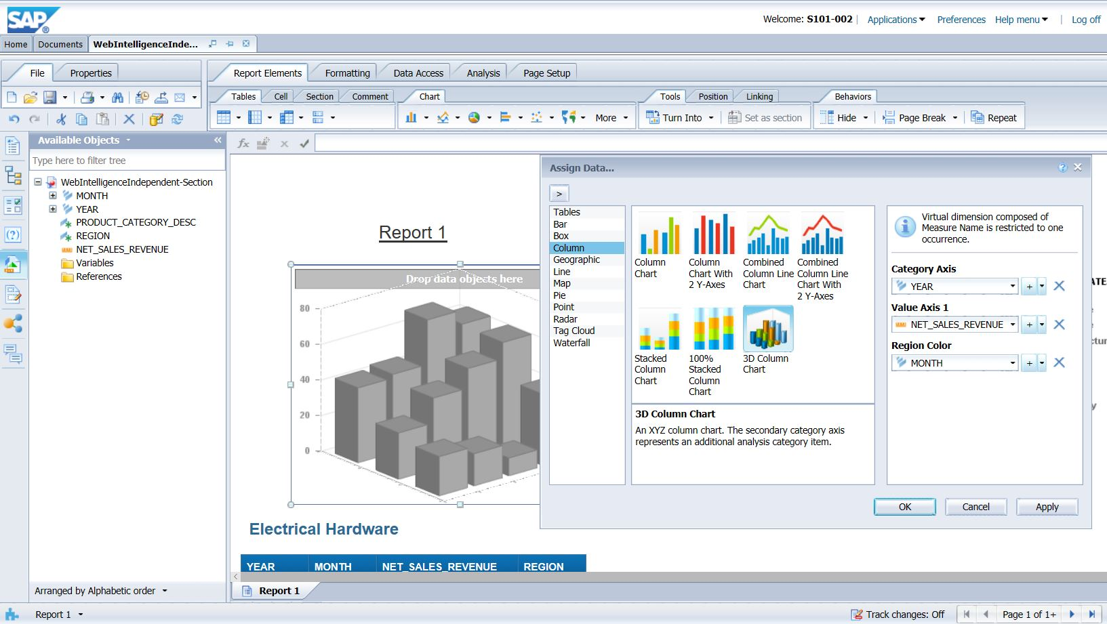

Resize the chart if necessary.

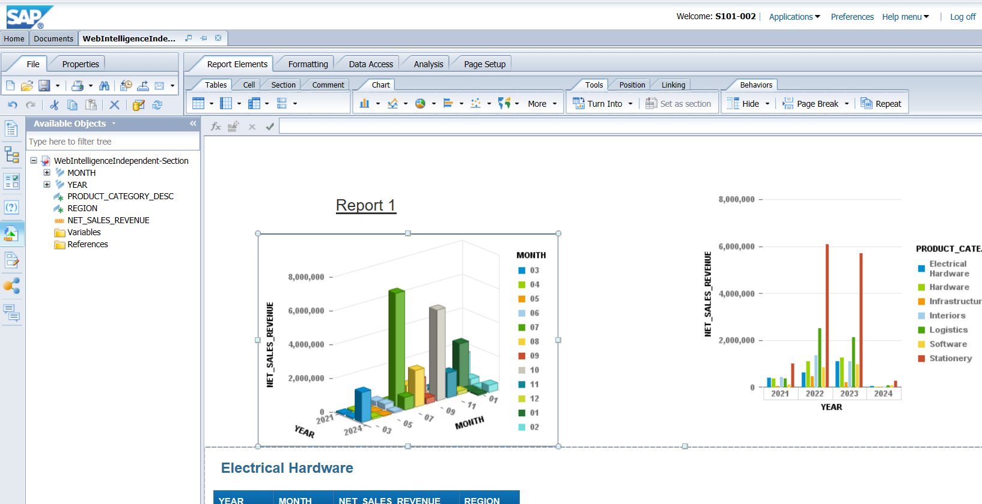

**2.7**

Now change the report title to “Sales Revenue Report“ and select the Report title box. Enter the text “Sales Revenue Report“ and click Enter. Please ensure that the 3D chart is include in your screenshot.

**Paste your screenshot.**

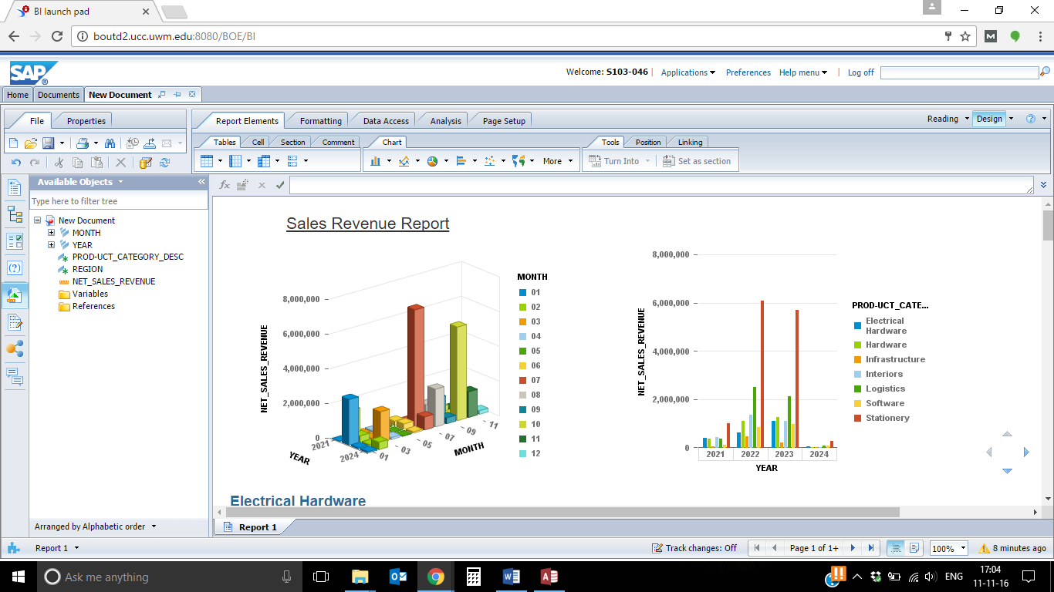

2.8

**Grouping**

In the above given graphs, different bars are representing different Product Categories. Grouping divided the Product Category Description in different sub groups. We apply grouping if we want to compare a particular Product Category with respect to all other categories. We will now apply the grouping on Product Category Description.

Drag the column chart on the canvas.

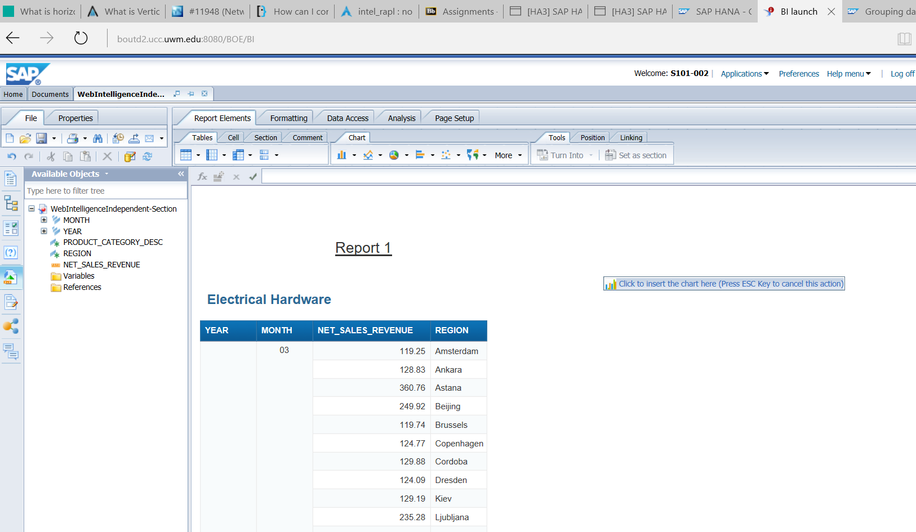

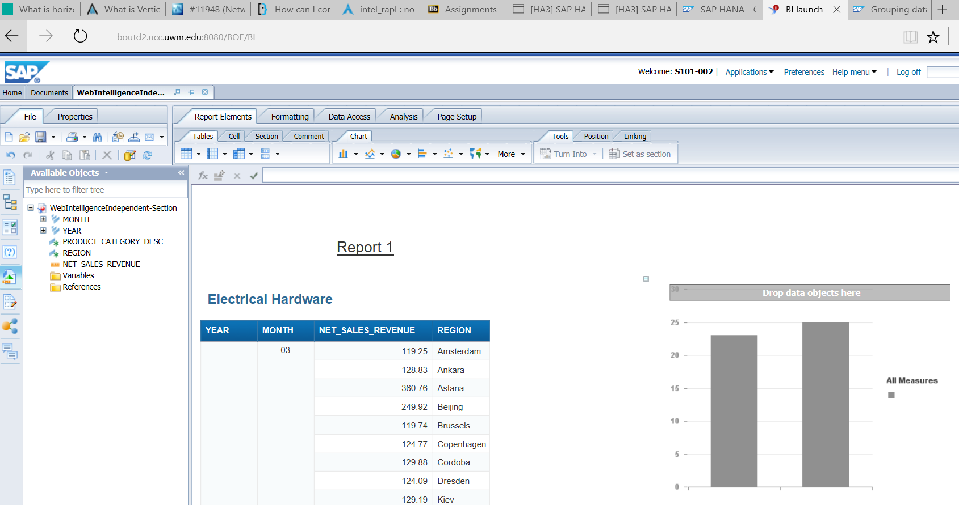

Right click on the graph. Click on Assign Data

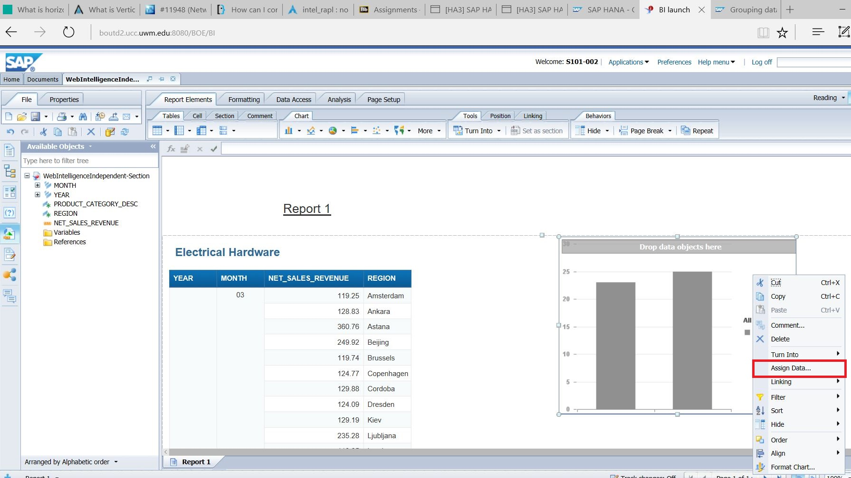

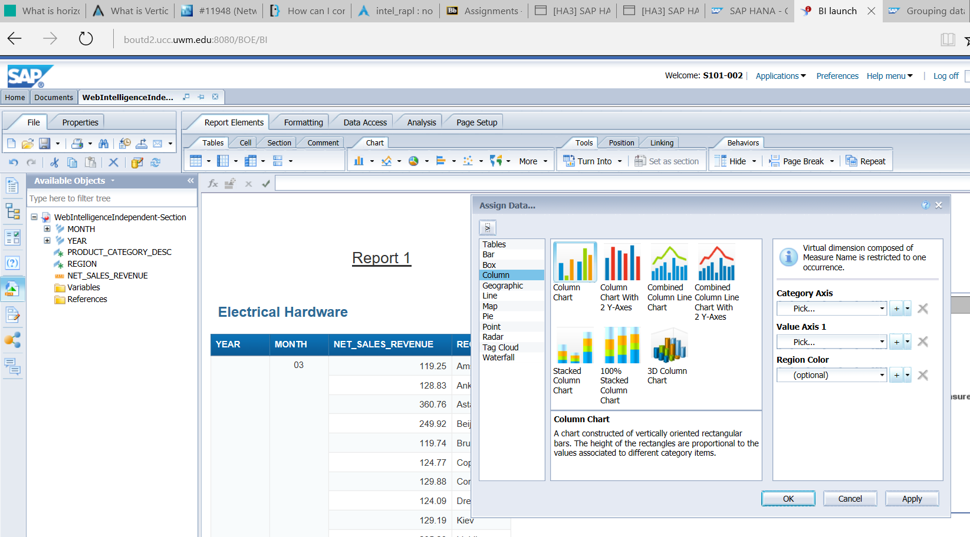

Choose Year for X axis, Net Sales Revenue for Y axis. For Z axis, click on small drop down button and choose Edit Formula.

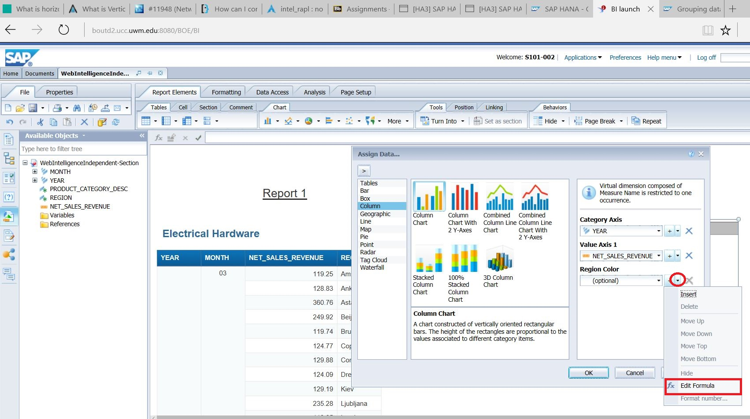

Put the below given formula in Formula pane:

=If[PRODUCT_CATEGORY_DESC]="Electrical Hardware" then "Electrical Hardware" Else "Other Categories"

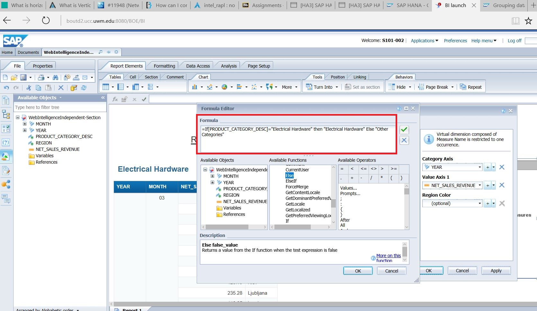

Now click on the below given check mark to validate the formula:

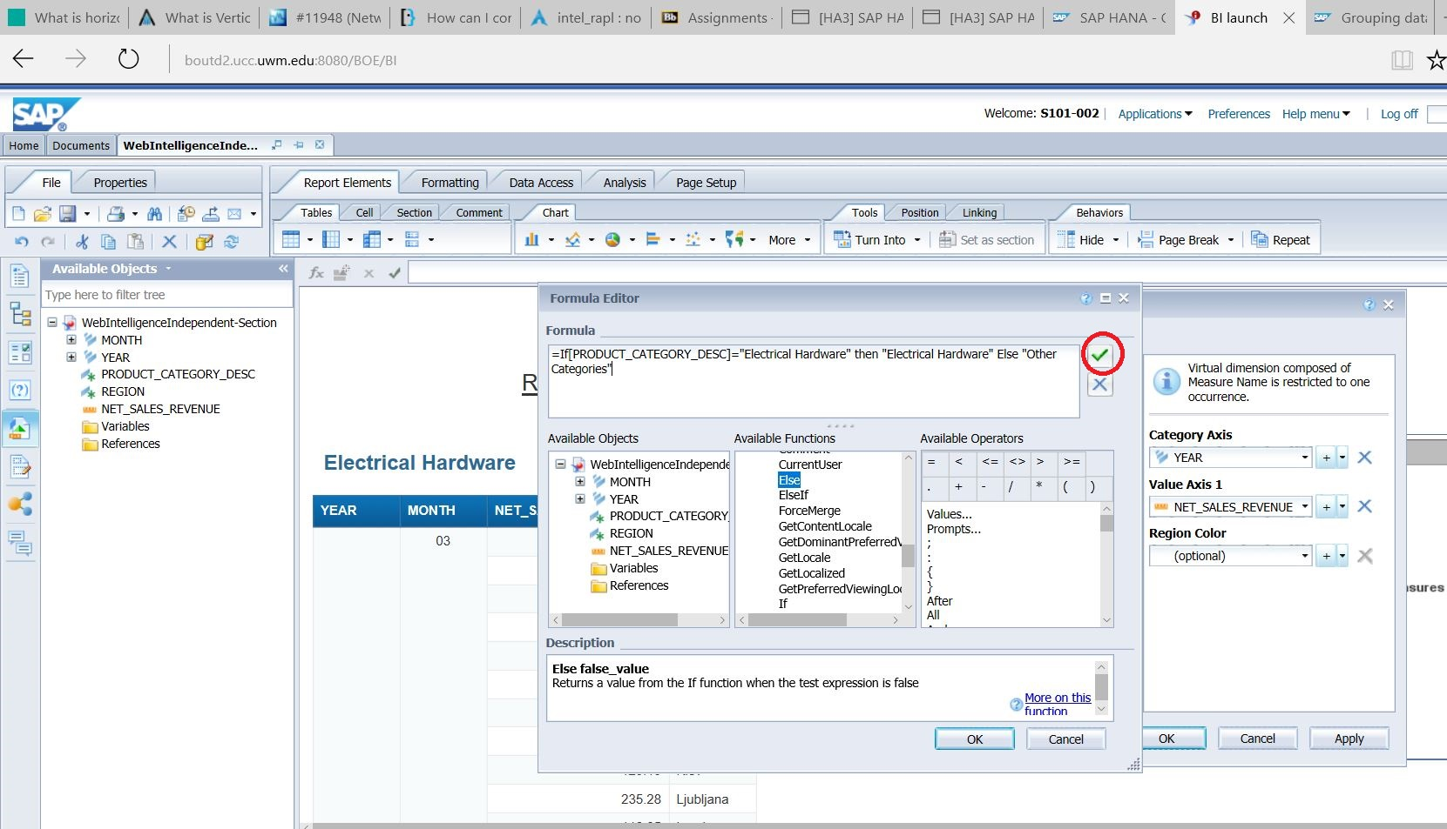

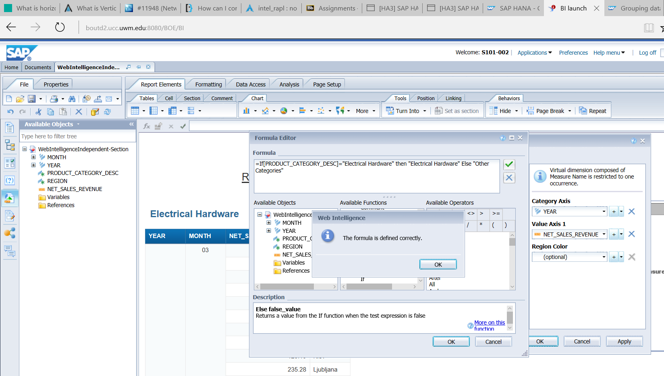

Click on OK and then again click on OK on formula editor. After that click on Apply and OK.

**Paste the screenshot below.**

